Parameter estimation of a groundwater representation applicable in a
global-scale land surface model
Sujan Koirala¹, Pat J.-F. Yeh², Taikan Oki², and Shinjiro Kanae¹
¹Tokyo Institute of Technology, Japan; ²University of Tokyo, Japan

- Introduction
Global-scale land surface models (LSMs) often parameterize the exchange of energy at land surface on a physical basis and hence are computationally demanding to numerically solve the complex relationship. However, ad hoc assumptions are made to conceptualize the runoﬀ generation mechanism and other relevant hydrological processes like the groundwater process. But, conceptualization of a process requires proper estimation of parameter.
In this study, a groundwater model [Yeh and Eltahir (2005a,b)] is incorporated into a global-scale land surface model (LSM) Minimal Advanced Treatments of Surface Interaction and Runoﬀ, MATSIRO [Takata et al. (2003)].
A lumped water balance equation for an unconﬁned groundwater reservoir can be expressed as,
(1)
where,
S_{y} [m³/m³]: is speciﬁc yield, d_{gw} [m]: water table depth (WTD), I_{gw} [kg/m²s]: net groundwater recharge, Q_{gw} [kg/m²s]: is base runoﬀ.
Based on observation for eight groundwater wells in Illinois region, base runoﬀ was formulated using a threshold mathematical relationship as,
(2)
where,
K [/mon]: outﬂow constant, d₀ [m]: threshold WTD

Since, the groundwater representation involves conceptualization, three additional parameters have been introduced; d₀, K, and S_{y}.
A sensitivity analysis of the parameters was carried out for Illinois region where an extensive amount of observation data is available for validation. The best values of parameters for Illinois region were estimated as, d₀= 3.50 [m], K= 40 [/mon], and S_{y} = 0.08 [m³/m³]. The hydrological ﬂuxes were most sensitive to d₀ in Illinois region. K had an eﬀect of scaling base runoﬀ but sensitivity was not as high as that to d₀. Sensitivity to S_{y} was also relatively low.
This study will focus on estimation of d₀ and K on global-scale such that the model can be used in global-scale evaluation of the eﬀect of groundwater representation on hydrological ﬂuxes.
- Global Estimation
Owing to the computational demand of global-scale LSM, the calibration process was minimized. First d₀ was estimated keeping K constant and then vice versa. S_{y} was assumed to be same as that for Illinois region for both set of simulations.
The simulation period for sensitivity analysis is from beginning of 1985 to end of 1994. First ﬁve years are left out as spin up years and simulation results from 1990 to 1994 are used for analysis. The target river basins selected for evaluation of performance of parameters are presented in Fig. 1.
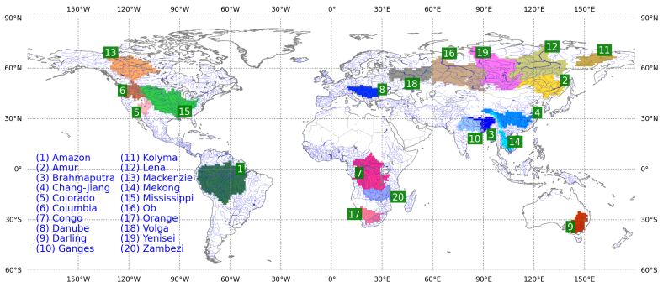
Figure 1: Target river basins for global-scale analysis

- Threshold WTD (d₀)
Using Nash-Sutcliﬀe (NS) coeﬃcient as major selection criteria, d₀ with the best simulation of river discharge in each target river basins was selected. For most river basins, NS value is around or over 50 percent, which is consistent with the accuracy in similar previous studies.
The correlation between the best d₀ and precipitation [Fig. 2a] is larger than that for river discharge [Fig. 2b].
It implies that d₀, in long run, is determined by precipitation amount. Rainfall, by controlling the soil moisture, implicitly controls the d₀ as well. Wet soil has
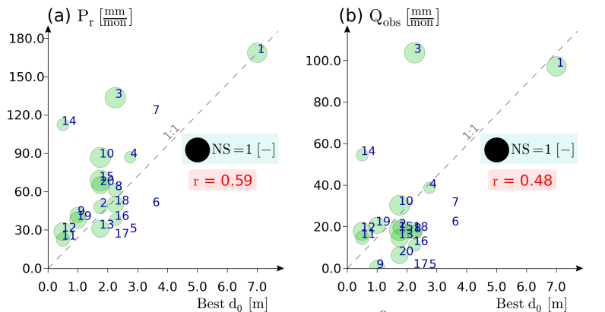
Figure 2: Threshold water table depth (d₀)[m] against hydro-climatic variables in target river basins (a) mean precipitation (b) observed monthly discharge (number besides circle indicates basin ID in Fig. 1)

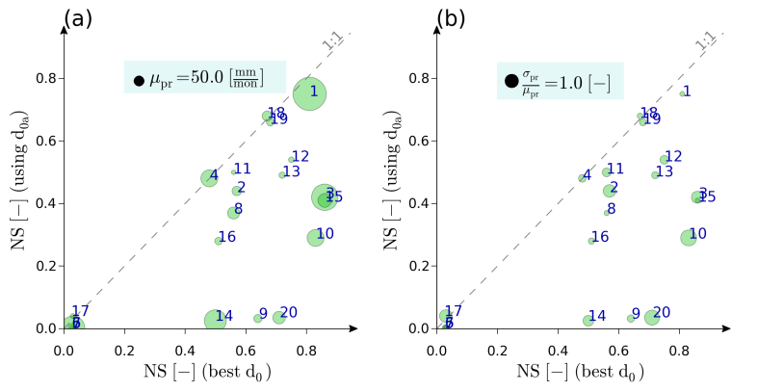
Figure 3: Evaluation of performance of the model based on threshold water table depth (d₀)[m] estimated from mean and standard deviation of precipitation against (a) the best runs (b) d₀ estimated from mean precipitation
(number besides circle indicates basin ID in Fig. 1)

high hydraulic conductivity which causes large inﬁltration and consequently base runoﬀ is the dominant runoﬀ generation mechanism.
Under this assumption, a relationship between d0 and precipitation can be formulated. One major advantage of choosing precipitation over discharge is the availability of grid-based global dataset with intra-basin spatial variability.
So, a linear proportionality between precipitation and d0 was assumed as,
(3)
But, small d0 results to large surface runoﬀ i.e. d0 should be reduced if coeﬃcient of variation of precipitation is large and vice versa. So, d₀ and CoV of precipitation are assumed to be inversely proportional to each other as Eq. 4,
(4)
Combining Eq. 3 with Eq. 4,
(5)
where, d_{0gr} is d0 for any grid print; d_{0Ill} is d₀ for Illinois [3.50m]; µ and σ are mean and standard deviation of precipitation; Ill-Illinois and gr-other grid point.
To validate the d₀ estimated using Eq. 5, NS coeﬃcient obtained for simulation using this d₀ is compared with NS coeﬃcient from the best runs obtained by calibration in Fig. 3. The comparison with the best runs is presented in Fig. 3a. d₀ estimated using mean and standard deviation of precipitation can reproduce the performance of the best runs in majority of river basins.

- Outﬂow Constant (K)
Similar to d0, the best K was selected for each basin based on comparison on river discharge. The outﬂow from a basin was relatively insensitive to drainage area. In macro-scale modeling, many controlling eﬀects compensate each other and average out [Brutsaert and Sugita (2008)].
Prediction of major hydrological ﬂuxes being similar for diﬀerent K, the values of estimated K can be used as a constant for the whole basin. For other regions, K = 20 can be used as majority of river basins have this as the best value. Since the sensitivity of hydrological ﬂuxes to K is low, it is unnecessary to devise a way to transfer K to other regions if we tradeoff between the potential improvement in performance and computational eﬃciency of the model.

References
Brutsaert, W. and M. Sugita, 2008: Is mongolia’s groundwater increasing or decreasing? the case of kherlen river basin. Hydrological Sciences, 53 (6).
Takata, K., S. Emori, and T. Watanabe, 2003: Development of minimal advanced treatments of surface interaction and runoﬀ. Global and Planetary Change, 38, 209–222.
Yeh, P. J.-F. and E. A. B. Eltahir, 2005a: Representation of water table dynamics in a land surface scheme. part i: Model development. Journal of Climate, 18, 1861–1880.
Yeh, P. J.-F. and E. A. B. Eltahir, 2005b: Representation of water table dynamics in a land surface scheme. part ii: Subgrid variability. Journal of Climate, 18, 1881–1901.
Keywords: Groundwater, Land surface model, parameter estimation.

