Global Modeling of Land Surface Hydrology with the Representation of Water Table Dynamics, Part I: Model Construction and Evaluation
Sujan Koirala¹, Pat J.-F. Yeh², Taikan Oki², and Shinjiro Kanae³
¹Institute of Engineering Innovation, University of Tokyo, Japan
²Department of Civil Engineering, University of Tokyo, Tokyo, Japan.
³Department of Mechanical and Environmental Informatics, Tokyo Institute of Technology, Tokyo, Japan.
Abstract. Land surface models (LSMs) used in climate models parameterize the exchanges of water and energy between land surface and the atmosphere on a physical basis. However, water table depth (WTD), a basic hydrologic quantity, has traditionally been neglected. In this study, a representation of water table dynamics is integrated into an LSM, the Minimal Advanced Treatments of Surface Integration and Runoﬀ (MATSIRO). Model evaluation conducted in Illinois with a comprehensive set of observed hydrological data shows signiﬁcant improvement over the original MATSIRO in simulations of runoﬀ, evapotranspiration (ET), and WTD. The model is then applied on global scale using globally-varying groundwater parameters estimated in the companion paper [Koirala et al., submitted]. Global mean ET increases by ∼9% when groundwater-supplied capillary ﬂux is considered. The semi-arid regions have the largest increase, with up to ∼25% in the Indian subcontinent. Increase in ET is relatively small in humid regions with suﬃcient moisture and high latitudes with limited radiation energy. Comparisons of global runoﬀ and ET simulations with previous estimates indicate improved resemblance in southeastern Africa, Indian subcontinent, and northern midlatitude when capillary ﬂux is considered. Signiﬁcant improvement in discharge simulations over some large river basins can also be found, and the model also reproduces the GRACE satellite-based observations of terrestrial water storage fairly well. Further, global groundwater recharge is estimated to be 29900 km³/yr and global pattern of WTD is found to be mainly controlled by climatic and soil properties.
1. Introduction
Land Surface Models (LSMs) were ﬁrst developed in 1960’s to represent land surface hydrologic processes in the General Circulation Models (GCMs). In the earliest incarnation [Manabe, 1969] commonly known as the ‘bucket model’, land surface runoﬀ is parameterized as overﬂow from a bucket whose size represents the water-holding capacity of soil. LSMs have since advanced considerably through the incorporation of sophisticated physical processes such as vegetation processes [e.g., Deardoﬀ, 1978; Sellers et al., 1986; Dickinson et al., 1986], runoﬀ generation [e.g., Famiglietti and Wood, 1994; Stieglitz et al., 1997; Liang and Xie, 2003; Niu et al., 2005], evapotranspiration (ET) [e.g., Dickinson, 1983; Sellers et al., 1997], and snow schemes [e.g., Hansen et al., 1983; Loth et al., 1993; Lynch-Stieglitz, 1994; Niu and Yang, 2006].
Despite these advancements, water table dynamics, a fundamental land surface hydrologic process, has been traditionally neglected or implicitly treated in LSMs, and hence near-surface groundwater (GW) is one of the hydrologic processes not robustly represented in current generation of GCMs [Lyon et al., 2008]. Numerous recent studies, however, have demonstrated the signiﬁcance of GW representation in LSM hydrological simulations [e.g., Famiglietti and Wood, 1991, 1994; Koster et al., 2000; Gutowski et al., 2002; York et al., 2002; Liang et al., 2003; Chen and Hu, 2004; Maxwell and Miller, 2005; Yeh and Eltahir, 2005a, b; Cohen et al., 2006; Niu et al., 2007; Fan et al., 2007; Maxwell et al., 2007; Huang et al., 2008; Maxwell and Kollet, 2008; Miguez-Macho et al., 2007, 2008; Kollet and Maxwell, 2008; Kollet, 2009; Ferguson and Maxwell, 2010; Lo and Famiglietti, 2010, 2011]. Water table dynamics controls runoﬀ generation mechanism [Niu et al., 2007] and enhances ET in dry season by acting as an additional source of root zone soil moisture. The increase in ET due to GW-supplied moisture has been estimated to be 7-21% in the Sand Hills of Nebraska [Chen and Hu, 2004], 5-20% in northeastern Kansas [York et al., 2002], and 4-16% at global scale [Niu et al., 2007]. Owing to large variations of climate, vegetation, and soil properties, the inﬂuence of water table dynamics on global-scale hydrological simulations is also variable. The LSM studies with representation of groundwater dynamics vary in the complexity of parameterizations and the spatial domain of application. Models with a complex representation (e.g., three-dimensional GW models) require the speciﬁcation of a large number of parameters and boundary conditions and hence are computationally demanding, which render them applicable only for smaller-scale studies [e.g., York et al., 2002; Maxwell and Miller, 2005]. The implementation of these GW models in global-scale LSMs is limited by the lack of parsimonious parameterization for water table dynamics as well as scarcity of observational data required for parameter estimation and model validation.
Among the aforementioned modeling studies with GW representation, only Niu et al. [2007] and Lo and Famiglietti [2011] were conducted at global scale. Both studies used the Community Land Model (CLM; Oleson et al. [2004]; Niu et al. [2005]) and assumed the GW parameters to be globally constant. Nonetheless, when GW-supplied capillary ﬂux was considered, consistently wetter soil moisture and higher ET were simulated [Niu et al., 2007] leading to precipitation increase in most global regions [Lo and Famiglietti, 2011].
Furthermore, even though the estimation of GW recharge is essential for global assessment of GW resources and its variability, its estimations on global scale are relatively few [e.g., Doll and Fiedler, 2008; Wada et al., 2010]. Doll and Fiedler [2008] estimated recharge as a fraction of total runoﬀ based on slope relief, soil texture, hydrogeology, permafrost, and precipitation intensity, while the upward capillary ﬂux from shallow GW was not considered. Wada et al. [2010] estimated recharge as the ﬂux between the lowermost soil layer and GW storage, while the dynamic interaction between them was not explicitly modeled. Due to these limitations, improvement in the estimation of GW recharge is desirable for global assessment of GW resources under current condition as well as future climate change scenarios. In this study, the representation of water table dynamics previously developed by Yeh and Eltahir [2005a, b] is incorporated into an LSM, namely the Minimal Advanced Treatments of Surface Integration and Runoﬀ (MATSIRO; Takata et al. [2003]). MATSIRO has been applied in hydrologic studies at both regional [Yoshimura et al., 2006, 2008] and global scales [Hirabayashi et al., 2005, 2008]. In the recent European Union Water and Global Change (EU-WATCH)-Water Model Intercomparison Project (WaterMIP), MATSIRO is the only model with the representation of water table dynamics among six participating LSMs [Haddeland et al., 2011].
Here, the simulations of MATSIRO with the representation of water table dynamics (MAT-GW) is ﬁrst validated against long-term in-situ observations in Illinois, and then the importance of water table dynamics on global-scale hydrologic simulations (runoﬀ, ET, root-zone soil moisture, WTD, and GW recharge) is evaluated. The MAT-GW is applied at global scale by using globally-varying GW parameters as estimated by Koirala et al. [submitted] (companion paper). In the section that follows, the model development is brieﬂy explained. In section 3, the performance of MATSIRO, both with and without the representation of water table dynamics, is evaluated against observations in Illinois. In section 4, the importance of capillary ﬂux is evaluated in global scale and simulations are compared with previous global-scale studies, and then river discharge and terrestrial water storage simulations are evaluated against observations at basin scale. The global simulations of WTD and GW recharge are also presented and discussed. Finally, the conclusions and future research directions are summarized in section 5.
2. Model Description
MATSIRO is the land surface scheme of an Atmospheric Ocean General Circulation Model, the Model for Interdisciplinary Research On Climate (MIROC; Hasumi et al. [2004]; Watanabe et al. [2010]), jointly developed by the Atmosphere and Ocean Research Institute at the University of Tokyo, the National Institute of Environmental Studies, and the Frontier Research Center for Global Change in Japan. Although the majority of hydrologic processes are physically represented in MATSIRO, it lacks a proper representation of GW processes. Here, a simple, lumped unconﬁned aquifer model [Yeh and Eltahir, 2005a, b] is integrated into MATSIRO. The structure of soil column, and WTD and baseﬂow calculations in the original MATSIRO (MAT-ORI) as well as MAT-GW is explained brieﬂy in the following.
2.1. MAT-ORI
A schematic representation of the MAT-ORI is presented in Figure 1. Energy ﬂuxes are calculated at both ground and canopy surfaces in the snow-free and snow-covered fractions of a grid cell considering subgrid snow distribution. Interception loss from the canopy and transpiration are estimated on the basis of photosynthesis scheme of SiB2 [Sellers et al., 1986, 1996]. Soil column is divided into ﬁve layers (Figure 2a) and the temperature and moisture (liquid and frozen) are calculated for each layer. The thickness of soil layers is 5, 20, 75, 100 and 200 cm respectively from ground surface. The WTD is implicitly estimated from the unsaturated matric potential of the lowermost soil layer as,
(1)
where dgw [L] is WTD (always <4 m), Zg [L] is the depth to the lowermost soil layer, and [L] is the unsaturated matric potential of the lowermost soil layer. The Richards’ equation [Richards, 1931] is solved for all soil layers irrespective of the location of water table as there is no explicit representation of saturated zone.
A simpliﬁed version of TOPMODEL [Beven and Kirkby, 1979] developed by Stieglitz et al. [1997] is adopted to represent runoﬀ process. Baseﬂow is calculated as,

(2)
where K0 [L T⁻¹] is the saturated hydraulic conductivity at ground surface, fatn [−] is the attenuation coeﬃcient of K0 with depth, tanβs [−] is the mean topographic slope within a grid cell, and Ls is the length of a conceptual hillslope which is inversely proportional to tanβs.
2.2. MAT-GW
A simple unconﬁned aquifer model is coupled to the soil model of MAT-ORI. One-dimensional lumped water balance equation for the unconﬁned aquifer can be expressed as,
(3)
where Sy [-] is the speciﬁc yield, dgw [L] is the WTD, Igw [L T⁻¹] is GW recharge to (when positive) or capillary rise from (when negative) the GW reservoir, and Qgw [L T⁻¹] is the baseﬂow. The diﬀerence between recharge and baseﬂow determines the ﬂuctuations of water table. The reservoir is nonlinear because both Igw and Qgw have complex nonlinear dependencies on dgw. The Igw depends on the degree of saturation of the lowermost soil layer. The GW reservoir is dynamic in that the exact location of the water table determines the number of soil layers in unsaturated zone, for which the soil moisture-based Richards’ equation is solved. Alternative solutions of soil moisture movement considering quasi steady-state condition [Bogaart et al., 2008] and equilibrium soil moisture condition [Zeng and Decker, 2009] have also been provided in the literature. If the water table is near root zone, the upward GW capillary ﬂux directly supplies moisture to root zone and aﬀects surface hydrological ﬂuxes. In order to accommodate the variable WTD and accurately locate its position, soil column is extended to 10 m below the ground surface -in total 12 layers with the depth of 5, 20, and 75 cm for the top 3 layers, and 1 m each for the remaining 9 layers. A schematic representation of the linkage of the soil-GW model in MAT-GW is presented in Figure 2b. Unlike MAT-ORI, the soil column now has an explicit representation of unsaturated and saturated zones separated by the water table. The two zones interact continuously through an exchange of moisture ﬂux (GW recharge) near the water table. It is assumed that the interaction between saturated and unsaturated zones become decoupled when the water table is deeper than 10 m.
The TOPMODEL-based baseﬂow in MAT-ORI (equation (2)) is replaced by the following threshold relationship developed based on observations in Illinois by Yeh and Eltahir [2005a]
(4)
where K [T⁻¹] is the outﬂow constant, and d0 [L] is the threshold WTD shallower than which baseﬂow is initialized. Both d0 and dgw are taken as positive values. Yeh and Eltahir [2005b] accounted for the subgrid heterogeneity of WTD by using a statistical-dynamical approach based on the spatial distribution of the observed WTD in Illinois. The derived grid-scale (macroscale) average baseﬂow (E [Qgw]) can be written as [Yeh and Eltahir, 2005b, equation (5)]
(5)
where Γ (α) is the Gamma function, and α and λ are the shape and scale parameters, respectively, of the assumed Gamma distribution of dgw. The d0, K and Sy are the main GW parameters. More physical interpretation of the GW parameters is provided in section 2 of the companion paper [Koirala et al., submitted], where the signiﬁcant issue of global-scale parameter estimation will be investigated.
3. Model Evaluation in Illinois
As the ﬁrst step to validate MAT-GW, an oﬄine simulation for a single point representing the Illinois state was carried out. In Illinois, a comprehensive set of long-term hydrologic data is uniquely available including direct observations of river discharge, soil moisture, WTD, as well as observation-based estimate of evaporation by Yeh et al. [1998]; Yeh and Famiglietti [2008] and GW recharge by Yeh and Famiglietti [2009].
To drive the oﬄine MATSIRO, eight atmospheric forcing variables are required: precipitation (rainfall and snowfall separately), downward shortwave and longwave radiations, speciﬁc humidity, wind speed, air temperature, and surface pressure. Precipitation and temperature were acquired from the National Climate Data Center (NCDC; http://www.ncdc.noaa.gov/oa/ncdc.html) Integrated Surface Hourly dataset. Speciﬁc humidity, pressure, wind speed, and solar radiation were taken from National Centers for Environmental Prediction/Department of Energy (NCEP/DOE) 6hourly reanalysis data [Kanamitsu et al., 2002] and linearly interpolated to the 3hourly resolution. In addition, solar radiation was bias-corrected by adjusting the monthly mean to be consistent with the NASA Surface Radiation Budget dataset (http://eosweb.larc.nasa.gov/PRODOCS/srb/table srb.html). Simulation is ﬁrst carried out for a 17-year (1984-2000) period, and the obtained climatologies of hydrologic states are used to initialize another 17-year (1984-2000) simulation for analysis with the ﬁrst year left out as the spin-up period. The GW parameters (d0, K and Sy) in Illinois are estimated by calibration against multiple hydrologic observations as presented by Koirala et al. [submitted, section 2]. A set of parameters that maximizes the Nash-Sutcliﬀe coefﬁcients [NS; Nash and Sutcliﬀe, 1973] (the NS is 1 for a perfect simulation) for multiple calibration objectives was estimated as d0=3.5 (m), K=40 (/mon) and Sy=0.04.
In the following, the results of both MAT-GW and MAT-ORI simulations are compared against the observations in Illinois. The long-term (1985-2000) mean hydrological ﬂuxes are presented in Table 1, while the comparisons of ET, total runoﬀ, GW recharge, top 2 m soil moisture, and WTD are shown in Figure 3. The mean total runoﬀ for both simulations are within a reasonable agreement (Table 1), but MAT-GW is closer to the observation and that simulated by Yeh and Eltahir [2005b]. The MAT-ORI fails to reproduce observed runoﬀ well (Figure 3b); in wet season it has higher peaks, while in dry season it is signiﬁcantly underestimated. It implies that the runoﬀ partitioning between fast (surface runoﬀ) and slow (baseﬂow) components is not realistic in MAT-ORI, possibly due to two reasons. First, the baseﬂow parameterization in MAT-ORI is proportional to the square of mean slope (see equation (2)), which is rather small on a typical grid size of LSM studies (50-250 km). Second, since GW aquifer is not formulated in MAT-ORI, time delay in baseﬂow generation cannot be simulated. Consequently, eﬀective rainfall in excess of soil moisture storage is either evaporated or runs oﬀ as surface runoﬀ. However, MAT-GW produces realistic partitioning of runoﬀ in both dry and wet seasons (Figure 3b). The comparison is contrasted by NS=0.63 of MAT-GW and =-0.57 of MAT-ORI.
Mean ET is overestimated in MAT-ORI (Table 1) simulation. In MAT-ORI, soil moisture is relatively wet as baseﬂow is biased low, and hence ET is seldom limited by moisture supply. The NS (=0.75) in MAT-GW is marginally improved compared to NS (=0.70) in MAT-ORI with slight increases in the summer peak of dry years (e.g., 1991, 1994, 1997 and 1999, Figure 3a).
The comparison between simulated GW recharge of MAT-GW and water balance-based estimate by Yeh and Famiglietti [2009] is presented in Figure 3c. As seen, MAT-GW simulates the seasonal variation of GW recharge fairly well (NS=0.57). When the soil is relatively dry, moisture ﬂux exchange between unsaturated and saturated zones becomes upward since capillary rise outweighs gravity drainage. The negative recharge in summer [Yeh and Famiglietti, 2009, Figure 4] is reproduced by MAT-GW. However, the long-term mean recharge is overestimated by MAT-GW (Table 1) as the simulated magnitude of negative recharge peak is smaller than that estimated by Yeh and Famiglietti [2009] (see Figure 3c).
The anomalies of WTD and soil moisture, instead of their absolute values, are compared as the total depth of soil column in MAT-ORI and MAT-GW are diﬀerent (Figure 3d-3e). In the MAT-ORI simulation, the timing of WTD ﬂuctuations is ∼2-3 months earlier than observations (Figure 3d). The WTD is directly calculated from the unsaturated matric potential in MAT-ORI (equation (1)), and hence its variations closely follow that of soil moisture, which generally responds to climatic forcing faster than GW. Also, amplitude of WTD ﬂuctuations in MAT-ORI is larger than observations and MAT-GW. In summary, the implicit representation of WTD using hydrostatic assumption of TOPMODEL in MAT-ORI does not fully reproduce observed WTD. In contrast, MAT-GW simulates the delay and amplitude of GW ﬂuctuations in response to recharge more realistically. As a result, NS improves from -0.10 (MAT-ORI) to 0.63 (MAT-GW).
Finally, a comparison of top 2 m soil moisture simulations and the corresponding observation is presented in Figure 3e, where it shows that MAT-ORI produces the largest amplitude. Summer drying of soil moisture is reduced by upward capillary ﬂux from GW, and spring soil moisture peaks in MAT-GW simulation are also closer to observations. As a result, NS improves from 0.55 (MAT-ORI) to 0.74 (MAT-GW).
4. Global Application of MAT-GW
In this section, MAT-GW is applied at global scale to identify the regions where the representation of water table dynamics has a signiﬁcant impact on hydrological simulations. Before applying the model, the optimal GW parameters were estimated at global scale (see Koirala et al. [submitted]). The MAT-GW simulations are evaluated against river discharge and terrestrial water storage (TWS) observations in 20 selected large river basins as well as against previous global-scale simulations [Dirmeyer et al., 2006; Hall et al., 2006; Zhang et al., 2010]. Finally, the global-scale GW recharge and WTD simulations are discussed and evaluated.
4.1. Model Setup and Data
To isolate the eﬀect of GW-supplied capillary ﬂux, a pair of simulations was carried out. The ﬁrst model simulation neglects GW capillary ﬂux to the unsaturated zone (hereafter referred to as NC), while the second one accounts for it (WC). The moisture ﬂux exchange between the saturated and unsaturated zones in two simulations is schematically shown in Figure 4. NC is similar to the ‘free gravity drainage’ boundary condition, commonly used in LSMs [Lohmann et al., 1998, Table 1] to simulate drainage (baseﬂow) from the lowermost soil layer [e.g., Dickinson et al., 1993; Bonan et al., 2002]. In NC, however, gravity drainage is not directly taken as baseﬂow as commonly assumed. Instead, in both NC and WC, baseﬂow is estimated using macroscale baseﬂow formula in equation (5), and the lower boundary of soil is dynamic as the length of unsaturated zone depends upon the exact location of water table. As such, the diﬀerence between two simulations can solely be attributed to the presence of GW capillary ﬂux.
Simulations were driven using the NCC forcing dataset with 1◦ × 1◦ spatial and 6hourly temporal resolutions [Ngo-Duc et al., 2005]. Simulation is ﬁrst carried out for a 15-year (1985-1999) period, and the obtained climatologies of hydrologic states are used to initialize another 15-year (1985-1999) simulation for analysis. This procedure is deemed necessary since it usually takes more than 10 years for the simulated WTD to reach equilibrium in the arid regions. The model time step is 1 hour. In addition to forcing data, leaf area index and forest ﬂoor albedo were taken from the Global Soil Wetness Project (GSWP-2; Dirmeyer et al. [2006]). The global distribution of soil was provided by the International Satellite Land Surface Climatology Project-Initiative II (ISLSCP-2; Hall et al. [2006]), and soil properties were estimated by following Cosby et al. [1984]. The global distribution of vegetation was provided by the International Geosphere-Biosphere Programme [Hansen et al., 2000], and vegetation properties were provided by the University of Wales.
The global simulations of runoﬀ and ET are evaluated against previous global-scale estimates such as the GSWP-2 multimodel ensemble simulations, composite runoﬀ ﬁeld provided in the ISLSCP-2 data archive, and satellite-based ET estimation by Zhang et al. [2009, 2010]. An overview of the data used is provided in Table 2. In GSWP-2, the use of multiple LSMs ensures that the systematic errors and biases often present in individual models are reduced. The ISLSCP-2 global runoﬀ dataset is an update to the University of New Hampshire-Global Runoﬀ Data Centre (UNH-GRDC) composite runoﬀ ﬁeld [see Koster et al., 2006]. The UNH-GRDC dataset combines the GRDC observed river discharge with water balance model-simulated spatial pattern of global runoﬀ [Fekete et al., 2002]. Moreover, Zhang et al. [2010] provided a satellite-based estimation of global ET using the modiﬁed Penman-Monteith approach and satellite-derived normalized diﬀerence vegetation index.
On the basin-scale, discharge simulations in 20 selected river basins are compared with the GRDC observations. To simulate river discharge, total runoﬀ output of MATSIRO is routed over global river networks using the Total Runoﬀ Integrating Pathways (TRIP; Oki and Sud [1998]). The ﬂow velocity is ﬁxed at 1.0 m/s globally in TRIP simulations. In global river routing, ﬂow velocities varying from 0.14 to 1.0 m/s have been used [see Oki et al., 1999, Table 1] with a typical global constant of 0.5 m/s in TRIP [e.g., Oki et al., 1999; Alkama et al., 2010]. In TRIP simulations considering delay by groundwater reservoir, however, a larger ﬂow velocity (0.5-1.0 m/s) has been recommended by Decharme et al. [2010].
The mean climatology (2002-2007) of TWS simulations is compared with the TWS estimated from the Gravity Recovery and Climate Experiment (GRACE; Tapley et al. [2004]; Swenson et al. [2006]; Yeh et al. [2006]). The version ‘dpc200711’ GRACE data [Chambers, 2006] as used by Kim et al. [2009] is used here. In order to compare with GRACE, extra NC and WC simulations from 1979 to 2007 were carried out using the Global Precipitation Climatology Centre (GPCC) precipitation [Rudolf and Rubel, 2005] -based forcing dataset by Kim et al. [2009].
4.2. Importance of Capillary Flux in Global Hydrology
Here, the eﬀect of GW capillary ﬂux is analyzed to demonstrate the importance of representation of water table dynamics in global-scale land surface hydrology. The diﬀerences between long-term (1986-1995) mean runoﬀ, ET, and root zone soil moisture in NC and WC, and their latitudinal proﬁle (zonal-means) are presented in Figure 5. Runoﬀ in NC is larger than that in WC in most global regions, with the largest diﬀerence in arid to wet transition regions such as sub-Saharan Sahel, southeastern Africa, and the Indian subcontinent (Figure 5a-Figure 5c). Globally, simulated runoﬀ decreases by ∼11.5% in WC. In the Indian subcontinent, the decrease is ∼25%, while in Africa, it is ∼15%. In high latitudes, and wet regions such as the Amazon and Congo basins, the diﬀerences between simulations are relatively small.
ET shows the opposite trend compared to runoﬀ (Figure 5e) and it increases by ∼9% globally in WC. The largest increase can be seen in 15ºS-30ºN and 40ºN-50ºN regions (Figure 5f) characterized by relatively low precipitation (Figure 5d) and suﬃcient net radiation (Figure 5h). In humid regions, the eﬀect of capillary ﬂux on ET is marginal due to suﬃcient moisture availability from precipitation. Globally, root zone saturation increases by ∼11.4% in WC with a signiﬁcant increase across the latitudinal proﬁle (Figure 5j) except in the wet regions. In high latitudes, although the root zone saturation degree in WC is ∼30% wetter than that in NC (Figure 5k), the incoming radiation is limited to increase ET (Figure 5h). To the contrary, in arid or semi-arid regions (e.g., the Sahara and much of Australia), there is a negligible increase in root zone soil moisture as the WTD (capillary ﬂux) is in general deep (weak). Therefore, it is signiﬁcant to represent the dynamic coupling between unsaturated and saturated zones such that the length of unsaturated zone, and magnitude of GW capillary ﬂux aﬀecting root zone moisture, depends upon the exact location of water table.
The spatial pattern of the increase in ET due to GW capillary ﬂux is consistent with Niu et al. [2007, Figure 7c], although they reported only ∼3.6% increase in global ET. In their study, the comparison was made between a ‘free gravity drainage’ case (drainage from the lowermost soil layer taken as baseﬂow) and a model with dynamic GW representation. While such an experimental setup provides a useful insight into the tendency, the actual inﬂuence of GW capillary ﬂux can be somewhat uncertain, since the amount and seasonal variation of baseﬂow, which aﬀects soil moisture simulation, is presumably diﬀerent in two cases. The spatial pattern of the increase in ET is also approximately consistent with the location of ‘hot spots’ for land-atmosphere interaction [Koster et al., 2004, Figure 1], i.e., the regions where coupling between soil moisture and precipitation is strong. Using a coupled GW-land-atmosphere simulation, Lo and Famiglietti [2011] predicted an increase in precipitation in the similar transition climatic regions when the GW capillary ﬂux was considered.
4.3. Evaluation of Global Simulations
4.3.1. Global-scale Evaluation
The comparison of long-term (1986-1995) mean global terrestrial hydrologic budgets with previous estimations is summarized in Table 3. While calculating the global volume, Antarctica and grid cells classiﬁed as continental ice, mainly located in Greenland, were excluded. In NC, global mean runoﬀ volume is overestimated compared to WC simulation. Runoﬀ ratio (runoﬀ divided by precipitation) in WC is also closer to that in ISLSCP-2 (Table 3). Since precipitation data in the present study, GSWP-2, and CRU data [New et al., 1999, 2000] used to adjust ISLSCP-2 runoﬀ, are diﬀerent (Table 3), the global pattern of runoﬀ ratio (instead of runoﬀ) is compared in Figure 6. The spatial patterns of runoﬀ ratio in both simulations correspond well with the GSWP-2 and ISLSCP-2 in most global regions. However, in mid-to high latitudes of the northern hemisphere, runoﬀ ratio diﬀers signiﬁcantly between NC and WC, GSWP-2, and ISLSCP-2. GSWP2 precipitation in the region is known to be overestimated due to the exaggeration of undercatch correction for snowfall [Decharme and Douville, 2006]. The uncertainty in precipitation is likely to be translated into much greater uncertainty in runoﬀ [Fekete et al., 2004]. Signiﬁcant diﬀerences between the runoﬀ ratios in NC and WC are found in the Indian sub-continent, sub-Saharan Sahel, and southeastern Africa, where the inﬂuence of GW capillary ﬂux is large (Figure 6). In these regions, runoﬀ ratio in WC is much closer to GSWP-2 and ISLSCP-2 than that in NC.
Mean baseﬂow in WC is closer to GSWP-2 baseﬂow than NC. However, both simulated and GSWP-2 baseﬂows are larger than 12000 km³/yr as estimated by Lvovich [1979] using a water balance approach developed for rivers in Russia. The global baseﬂow ratio (baseﬂow divided by total runoﬀ) in both NC (0.75) and WC (0.78) simulations are larger than that in GSWP-2 (0.67). In both simulations, baseﬂow is primarily generated in humid regions, e.g., the Amazon and Congo basins together produce ∼27% (8035 km³/yr) of the global volume in WC. GW runoﬀ generated from coastal grids is estimated to be ∼15% of the global total runoﬀ in WC, slightly larger than previous estimate of direct GW discharge into the ocean (∼10%) [Zektzer, 1973; Church, 1996; Oki and Kanae, 2006]. Surface runoﬀ in both simulations are smaller than that in GSWP-2. Major surface runoﬀ generation mechanisms considered in MATSIRO are saturation excess [Dunne, 1978] and inﬁltration excess [Horton, 1933]. Saturation excess runoﬀ is dependent on the saturated area fraction within a grid, and hence it is large in regions with shallow WTD where the tendency to produce large baseﬂow is also high. Inﬁltration excess runoﬀ occurs when eﬀective rainfall is larger than the inﬁltration capacity, which is assumed to be equal to the saturated hydraulic conductivity. However, grid-average precipitation generated from GCMs is usually known to have biased low intensity, which tends to inhibit inﬁltration excess runoﬀ generation.
In WC, mean ET is similar to that by GSWP-2 (Table 3), and its spatial pattern also corresponds well with that by GSWP-2 and Zhang et al. [2010] (Figure 7). Further, a band of increased ET across central Europe and North America as simulated by both GSWP-2 and Zhang et al. [2010], can be reproduced only in WC (Figure 7b). However, ET in the Indian subcontinent and southeastern Africa in WC compares well with that by GSWP-2 only. Zhang et al. [2010] report underestimation of the satellite-based ET by ∼20% in the same regions, possibly causing the mismatch with WC simulation.
4.3.2. Basin-scale Evaluation
The comparison of river discharge simulations against GRDC observations in selected 20 large river basins is presented in Figure 8. For both NC and WC, the seasonal cycle of river discharge is well reproduced in the majority of basins with NS >0.50, comparable to the accuracy attained in previous global-scale modeling studies [e.g., Nijssen et al., 2001; Doll et al., 2003]. In humid basins such as Amazon, Brahmaputra, and Chang-Jiang, the diﬀerence between NC and WC simulations is small. In contrast, the consideration of capillary ﬂux is more important in the Ganges and Zambezi River basins, where mean discharges decrease from 50 to 33 mm/mon, and 18 to 7 mm/mon, for NC and WC, respectively. The NS also improve from 0.62 (NC) to 0.85 (WC) in Ganges and from -4.03 to 0.84 in Zambezi.
The performances in the Colorado, Columbia and Congo River basins are relatively poor for both simulations. In Colorado and Columbia, substantial human inﬂuences are likely to be the main reason. Human inﬂuence modules have just recently been implemented in MATSIRO [Pokhrel et al., under revision]. In Congo, Nijssen et al. [2001] and Doll et al. [2003] also reported relatively weaker performance even after extensive calibration, suggesting a possible inconsistency between the forcing and validation data. In Brahmaputra, river discharges for both NC and WC are slightly lower than observation.
Observed runoﬀ ratio is ∼80%, which is signiﬁcantly larger than that in the nearby Ganges (∼38%). In high latitude rivers (Kolyma, Lena and Yenisei), peak discharge, which is aﬀected by frozen soil condition and snowmelt timing, cannot be well reproduced in both simulations. As an explicit representation of snow physics is required to improve snow ablation process and snowmelt-caused runoﬀ peak [Luo et al., 2003], a rather simple snow scheme in the current MATSIRO may not be able to simulate the peak accurately.
The comparison of the mean climatology (2002-2007) of TWS anomaly (TWSA) simulations, which includes anomalies of canopy, snow, soil moisture, and GW storages, with the GRACE-based TWSA is presented in Figure 9. The diﬀerence between TWSA in NC and WC simulations is relatively small compared to river discharge (Figure 8). The improvement is only signiﬁcant in the Zambezi River basin for WC simulation. In humid basins such as Amazon, Chang-Jiang and Danube, both simulations reproduce GRACE data better than in drier basins (such as Colorado, Darling and Orange), where the simulated TWSA amplitude is marginally larger than GRACE. However, in the Amur basin, a large diﬀerence can be seen between simulations and GRACE. In most basins, the phase of TWSA simulations also compare fairly well with GRACE. In high latitude basins such as the Kolyma, Ob and Lena, the drying of TWSA is slightly earlier than GRACE, probably due to the simple snow scheme used in MATSIRO.
4.4. Global Simulations of WTD and Groundwater Recharge
Globally, mean GW recharge in WC is 29900 km³/yr (Table 3). GW recharge decreases by 4000 km³/yr when GW capillary ﬂux is considered. The simulated global recharge is larger than previous estimates of 12700 km³/yr [Doll and Fiedler, 2008] and 15200 km³/yr [Wada et al., 2010]. In the long term (without human inﬂuences), the recharge should be balanced by baseﬂow. The global GW recharge in WC is closer to the GSWP-2 multimodel average baseﬂow (30200 km³/yr) than previous estimates. However, global-scale validation of GW recharge is still not possible due to scarcity of reliable observational data. The global distributions of long-term mean GW recharge and WTD in WC are presented in Figure 10. Humid regions like the Amazon, Congo, and southeastern Asia have the largest GW recharge (>1000 mm/yr, Figure 10a). Both the previous studies estimated smaller recharge in humid region compared to WC simulation contributing to the large disparity in global volume. In WC simulation, arid and semi-arid regions have small recharge because of low precipitation and high evaporation. Also, high latitude regions have relatively smaller recharge because of low inﬁltration due to frozen soil.
As regarding global WTD pattern, climate, soil, and topographical properties are, in general, the main controlling factors as they inﬂuence GW recharge and baseﬂow. A shallow WTD may reﬂect either large inﬁltration, governed by climatic condition, or poor drainage condition, governed by soil and topographical characteristics. In Figure 10b, the global pattern of WTD is found to be mainly controlled by recharge, baseﬂow and soil properties. Understandably, the WTD is deeper in dry regions whereas it is shallower in humid regions. Streamﬂow network (drainage density) and other hillslope terrain attributes also have critical inﬂuences on baseﬂow and WTD. However, these eﬀects work at smaller spatial scales and their control at the grid-size scale of the global simulation may be secondary. As in most LSMs, topography and lateral ﬂow between grid cells are not explicitly considered in MAT-GW, and hence the simulated WTD pattern does not bear any relationship with topography. Additional smaller-scale heterogeneities in simulated WTD distribution are caused by the diﬀerence in soil properties, e.g., in Amazon, the grid cells with a loamy soil usually have a deeper WTD than that in clayey grid cells (Figure 10b). Under a similar climate, regions with clayey soils may have a shallower WTD compared to regions with loamy soils, as the drainage in the latter case is more eﬃcient. The spatial pattern of the simulated WTD compares fairly well with that by Niu et al. [2007, Figure 2c], however, the magnitude is diﬀerent especially in arid areas and regions with permeable soils (e.g., some areas within Amazon basin).
5. Summary and Conclusions
A representation of water table dynamics is integrated into a global-scale LSM, the MATSIRO. The model simulations are evaluated against direct observations in Illinois and 20 selected large river basins, as well as against previous global-scale simulations. The inﬂuence of GW-supplied capillary ﬂux on global-scale hydrological simulations is investigated, and the global distribution of GW recharge and WTD is analyzed.
Based on comparisons of simulations against multiple observations in Illinois, the representation of water table dynamics improves the simulations of both hydrological ﬂuxes and states. The NS improves from -0.57 to 0.63 for runoﬀ simulation, and from -0.10 to
0.63 for WTD simulation, producing accuracy similar to that by Yeh and Eltahir [2005b] and Lo et al. [2008, 2010]. Incorporation of GW aquifer delays the runoﬀ generation and hence produces more realistic baseﬂow, while the water storage simulation has smaller amplitude due to supply of GW capillary ﬂux.
Moreover, while carrying out the global simulations, globally varying GW parameters estimated by Koirala et al. [submitted] are used, which is an advance to assuming globally constant parameters [e.g., Niu et al., 2007; Lo and Famiglietti, 2011].
Globally, the mean ET increases by ∼9% due to GW capillary ﬂux. The spatial pattern of the increase in ET corresponds well with the work by Niu et al. [2007]. The increase in ET leads to an 11.5% decrease in runoﬀ. Despite widespread increase in root zone soil moisture (∼11%), the increase in ET exhibits large spatial variability. Wet regions show a negligible increase as moisture available from precipitation is already suﬃcient to support available radiation, whereas high latitudes also have a small increase as the available radiation itself is limited. In addition to the climatic variability, increase in ET should also be a function of soil and vegetation properties, but these controls, outside the scope of this paper, will be left for future study.
In most global regions, both simulations, with and without capillary ﬂux, can fairly reproduce the spatial patterns of runoﬀ ratio and ET compared to the GSWP-2 multimodel average [Dirmeyer et al., 2006], ISLSCP-2 runoﬀ ratio [Hall et al., 2006], and satellite-based ET [Zhang et al., 2010]. However, in the regions strongly aﬀected by capillary ﬂux such as the Indian subcontinent, southeastern Africa and sub-Saharan Sahel, the simulation improves signiﬁcantly only when capillary ﬂux is considered. This is further justiﬁed by large improvement in NS of river discharge simulations in Ganges (0.62 to 0.85) and Zambezi (-4.03 to 0.84) River basins. The inﬂuence of GW capillary ﬂux in TWS simulation is found to be relatively lower than runoﬀ and ET with both simulations reproducing GRACE data fairly well in the majority of river basins.
The simulated global GW recharge (29900 km³/yr) in this study is larger than previous model-based estimates (12700 km³/yr by Doll and Fiedler [2008] and 15200 km³/yr by Wada et al. [2010]), but it corresponds well with long-term mean baseﬂow estimate by GSWP-2 (30200 km³/yr). The uncertainty in estimating GW recharge is still large owing to the scarcity of global-scale hydrological observations that can be used to constrain or validate model simulations [Lo et al., 2010]. The global pattern of WTD is found to be mainly controlled by climatic conditions and then by soil characteristics. Moreover, global-scale direct GW discharge into the ocean is estimated to be ∼15% of the total runoﬀ.
Acknowledgments. The ﬁrst author acknowledges the support of the Ministry of Education, Culture, Sports, Science and Technology (MEXT) during his Ph.D., and Core Research of Evolutional Science & Technology (CREST) project of Japan Science and Technology Agency (JST) afterwards. We also express our gratitude to KAKUSHIN Program of the MEXT for supporting the second author. This work was also partially supported by Japan Society for the Promotion of Science (JSPS)-KAKENHI, Grant-in-Aid for Scientiﬁc Research (S) (19106008). Finally, we thank Dr. Hyungjun Kim for providing us with the forcing and validation datasets.
References
Alkama, R., et al., 2010: Global evaluation of the ISBA-TRIP continental hydrological system. Part I: Comparison to GRACE terrestrial water storage estimates and in situ river discharges. J. Hydrometeorol., 11 (3), 583–600, doi:10.1175/2010JHM1211.1.
Beven, K. J. and M. J. Kirkby, 1979: A physically based variable contributing area model of basin hydrology. Hydrol. Sci. Bull., 24, 43–69, doi:10.1080/02626667909491834.
Bogaart, P., A. Teuling, and P. Troch, 2008: A state-dependent parameterization of saturated-unsaturated zone interaction. Water Resour. Res, 44, W11 423, doi: 10.1029/2007WR006487.
Bonan, G. B., K. W. Oleson, M. Vertenstein, S. Levis, X. Zeng, Y. Dai, R. E. Dickinson, and Z.-L. Yang, 2002: The land surface climatology of the Community Land Model coupled to the NCAR community climate model. J. Clim., 15 (22), 3123–3149, doi: 10.1175/1520-0442(2002)015<3123:TLSCOT>2.0.CO;2.
Chambers, D. P., 2006: Evaluation of new GRACE time-variable gravity data over the ocean. Geophys. Res. Lett., 33 (17), L17 603, doi:10.1029/2006GL027296.
Chen, X. and Q. Hu, 2004: Groundwater inﬂuences on soil moisture and surface evaporation. J. Hydrol., 297 (1-4), 285–300, doi:10.1016/j.jhydrol.2004.04.019.
Church, T. M., 1996: An underground route for the water cycle. Nature, 380, 579–580, doi:10.1038/380579a0.
Cohen, D., M. Person, R. Daannen, S. Locke, and Coauthors, 2006: Groundwater-supported evapotranspiration within glaciated watersheds under conditions of climate change. J. Hydrol., 230, 484–500, doi:10.1016/j.jhydrol.2005.07.051.
Cosby, B. J., G. M. Hornberger, R. B. Clapp, and T. R. Ginn, 1984: A statistical exploration of the relationships of soil moisture characteristics to the physical properties of soils. Water Resour. Res., 20 (6), 682–690, doi:10.1029/WR020i006p00682.
Deardoﬀ, J. W., 1978: Eﬃcient prediction of ground surface temperature and moisture with inclusion of a layer of vegetation. J. Geophys. Res., 83, 1889–1903, doi: 10.1029/JC083iC04p01889.
Decharme, B., R. Alkama, H. Douville, M. Becker, and A. Cazenave, 2010: Global evaluation of the ISBA-TRIP continental hydrological system. Part II: Uncertainties in river routing simulation related to ﬂow velocity and groundwater storage. J. Hydrometeorol., 11 (3), 601–617, doi:10.1175/2010JHM1212.1.
Decharme, B. and H. Douville, 2006: Uncertainties in the GSWP-2 precipitation forcing and their impacts on regional and global hydrological simulations. Clim. Dynam., 27, 695–713, doi:10.1007/s00382-006-0160-6.
Dickinson, R., A. Henderson-Sellers, and P. Kennedy, 1993: Biosphere Atmosphere Transfer Scheme (BATS) version le as coupled to the NCAR Community Climate Model. Tech. Rep. TN-387 + STR (1993), NCAR Tech. Note.
Dickinson, R. E., 1983: Land surface processes and climate–surface albedos and energy balance. Theory of Climate, Proceedings of a Symposium Commemorating the Two-Hundredth Anniversary of the Academy of Sciences of Lisbon, B. Saltzman, Ed., Else-vier, Advances in Geophysics, Vol. 25, 305 – 353, doi:10.1016/S0065-2687(08)60176-4.
Dickinson, R. E., P. A. Kennedy, A. Henderson-Sellers, and M. Wilson, 1986: Biosphere-Atmosphere Transfer Scheme (BATS) for the NCAR Community Climate Model. Tech. Rep. NCAR/TN-275+STR, NCEP/NCAR.
Dirmeyer, P. A., X. Gao, M. Zhao, G. Zhichang, T. Oki, and N. Hanasaki, 2006: GSWP
2: Multimodel analysis and implications for our perception of the land surface. B. Am. Meteorol. Soc., 87 (10), 1391–1397, doi:10.1175/BAMS-87-10-1381. Doll, P. and K. Fiedler, 2008: Global-scale modeling of groundwater recharge. Hydrol. Earth Syst. Sc., 12, 863–865, doi:10.5194/hess-12-863-2008.
Doll, P., F. Kaspar, and B. Lehner, 2003: A global hydrological model for deriving water availability indicators: model tuning and validation. J. Hydrol., 270 (1), 105–134, doi: 10.1016/S0022-1694(02)00283-4.
Dunne, T., 1978: Field studies of hillslope ﬂow processes. Hillslope Hydrology, John Wiley and Sons, Chichester, U.K., 227–293 pp.
Famiglietti, J. S. and E. F. Wood, 1991: Evapotranspiration and runoﬀ from large land areas: Land surface hydrology for atmospheric general circulation models. Surv. Geophys., 12, 179–204, doi:10.1007/BF01903418.
Famiglietti, J. S. and E. F. Wood, 1994: Multi-scale modeling of spatially-variable water and energy balance processes. Water Resour. Res., 30 (11), 3061–3078, doi: 10.1029/94WR01498.
Fan, Y., G. Miguez-Macho, C. P. Weaver, R. Walko, and A. Robock, 2007: Incorporating water table dynamics in climate modeling, Part I: Water table observations and the equilibrium water table simulations. J. Geophys. Res., 112 (D10125), doi: 10.1029/2006JD008111.
Fekete, B. M., C. J. V¨or¨osmarty, and W. Grabs, 2002: High-resolution ﬁelds of global runoﬀ combining observed river discharge and simulated water balances. Global Biogeochem. Cycles, 16 (3), 1042, doi:10.1029/1999GB001254.
Fekete, B. M., C. J. V¨or¨osmarty, J. O. Roads, and C. J. Willmott, 2004: Uncertainties in precipitation and their impacts on runoﬀ estimates. J. Clim., 17 (2), 294–304, doi: 10.1175/1520-0442(2004)017<0294:UIPATI>2.0.CO;2.
Ferguson, I. M. and R. M. Maxwell, 2010: Role of groundwater in watershed response and land surface feedbacks under climate change. Water Resour. Res., 46, W00F02, doi:10.1029/2009WR008616.
Gutowski, W. J., C. J. V¨or¨osmarty, M. Person, Z. Otles, B. M. Fekete, and J. P. York, 2002: A Coupled Land-Atmosphere Simulation Program (CLASP): Calibration and validation. J. Geophys. Res., 107 (4283), doi:10.1029/2001JD000392.
Haddeland, I., et al., 2011: Multi-model estimate of the global terrestrial water balance: Setup and ﬁrst results. J. Hydrometeorol., doi:10.1175/2011JHM1324.1, in press.
Hall, F. G., et al., 2006: ISLSCP Initiative II global data sets: Surface boundary conditions and atmospheric forcings for land-atmosphere studies. J. Geophys. Res., 111 (D22), D22S01, doi:10.1029/2006JD007366.
Hansen, J., G. Russell, D. Rind, P. Stone, A. Lacis, S. Lebedeﬀ, R. Ruedy, and L. Travis, 1983: Eﬃcient three-dimensional global models for climate studies: Models i and ii. Mon. Weather Rev., 111 (4), 609–662, doi:10.1175/15200493(1983)111<0609:ETDGMF>2.0.CO;2.
Hansen, M. C., R. S. Defries, J. R. G. Townshend, and R. Sohlberg, 2000: Global land cover classiﬁcation at 1km spatial resolution using a classiﬁcation tree approach. Int. J. Remote Sens., 21 (6-7), 1331–1364, doi:10.1080/014311600210209.
Hasumi, H., S. Emori, A.-O. A., and co authors, 2004: K-1 coupled GCM (MIROC) description. Tech. Rep. 1, Center for Climate System Research (CCSR), University of Tokyo and National Institute of Environmental Studies (NIES) and Frontier Research Center for Global Change (FRCGC).
Hirabayashi, Y., S. Kanae, S. Emori, T. Oki, and M. Kimoto, 2008: Global projections of changing risks of ﬂoods and droughts in a changing climate. Hydrolog. Sci. J., 53 (4), 754–772, doi:10.1623/hysj.53.4.754.
Hirabayashi, Y., S. Kanae, I. Struthers, and T. Oki, 2005: A 100-year (1901-2000) global retrospective estimation of the terrestrial water cycle. J. Geophys. Res., 110 (D19), D19 101, doi:10.1029/2004JD005492.
Horton, R. E., 1933: The role of inﬁltration in the hydrologic cycle. EOS Trans. AGU, 14, 446–460.
Huang, M., X. Liang, and L. R. Leung, 2008: A generalized subsurface ﬂow parameterization considering subgrid spatial variability of recharge and topography. J. Hydrometeorol., 9 (6), 1151–1171, doi:10.1175/2008JHM936.1.
Kanamitsu, M., W. Ebisuzaki, J. Woollen, S.-K. Yang, J. J. Hnilo, M. Fiorino, and G. L. Potter, 2002: NCEP-DOE AMIP-II Reanalysis (R-2). B. Am. Meteorol. Soc., 83, 1631– 1643, doi:10.1175/BAMS-83-11-1631.
Kim, H., P. J.-F. Yeh, T. Oki, and S. Kanae, 2009: Role of rivers in the seasonal variations of terrestrial water storage over global basins. Geophys. Res. Lett., 36 (17), L17 402, doi:10.1029/2009GL039006.
Koirala, S., P. J.-F. Yeh, T. Oki, and S. Kanae, submitted: A global modeling of land surface hydrology with the representation of water table dynamics, Part II: Parameter estimation. J. Geophys. Res.
Kollet, S., 2009: Inﬂuence of soil heterogeneity on evapotranspiration under shallow water table conditions: transient, stochastic simulations. Environ. Res. Lett., 4, 035 007, doi: 10.1088/1748-9326/4/3/035007.
Kollet, S. and R. Maxwell, 2008: Capturing the inﬂuence of groundwater dynamics on land surface processes using an integrated, distributed watershed model. Water Resour. Res., 44 (2), W02 402, doi:10.1029/2007WR006004.
Koster, R. D., P. A. Dirmeyer, Z. Guo, G. Bonan, E. Chan, and Coauthors, 2004: Regions of strong coupling between soil moisture and precipitation. Science, 305, 1138–1140, doi:10.1126/science.1100217.
Koster, R. D., B. M. Fekete, G. J. Huﬀman, and P. W. J. Stackhouse, 2006: Revisiting a hydrological analysis framework with International Satellite Land Surface Climatology Project Initiative 2 rainfall, net radiation, and runoﬀ ﬁelds. J. Geophys. Res., 111 (D22), D22S05, doi:10.1029/2006JD007182.
Koster, R. D., M. J. Suarez, A. Ducharne, M. Stieglitz, and P. Kumar, 2000: A catchment-based approach to modeling land surface processes in a GCM, Part 1, model structure. J. Geophys. Res., 105, 24 809–24 822, doi:10.1029/2000JD900327.
Liang, X. and Z. Xie, 2003: Important factors in land-atmosphere interactions: surface runoﬀ generations and interactions between surface and groundwater. Global Planet. Change, 38 (1-2), 101–114, doi:10.1016/S0921-8181(03)00012-2.
Liang, X., Z. Xie, and M. Huang, 2003: A new parameterization for surface and groundwater interactions and its impact on water budgets with the variable inﬁltration capacity (VIC) land surface model. J. Geophys. Res., 108 (8613), doi:10.1029/2002JD003090.
Lo, M.-H. and J. S. Famiglietti, 2010: Eﬀect of water table dynamics on land surface hydrologic memory. J. Geophys. Res., 115 (D22), D22 118, doi:10.1029/2010JD014191.
Lo, M.-H. and J. S. Famiglietti, 2011: Precipitation response to land subsurface hydrologic processes in atmospheric general circulation model simulations. J. Geophys. Res., 116 (D5), D05 107, doi:10.1029/2010JD015134.
Lo, M.-H., J. S. Famiglietti, P. J.-F. Yeh, and T. H. Syed, 2010: Improving parameter estimation and water table depth simulation in a land surface model using GRACE water storage and estimated baseﬂow data. Water Resour. Res., 46 (5), doi: 10.1029/2009WR007855.
Lo, M.-H., P. J.-F. Yeh, and J. S. Famiglietti, 2008: Constraining water table depth simulations in a land surface model using estimated baseﬂow. Adv. Water Resour., 31 (12), 1552–1564, doi:10.1016/j.advwatres.2008.06.007.
Lohmann, D., et al., 1998: The Project for Intercomparison of Land-surface Parameterization Schemes (PILPS) phase 2(c) Red-Arkansas River basin experiment:: 3. spatial and temporal analysis of water ﬂuxes. Global Planet. Change, 19 (1-4), 161 – 179, doi:10.1016/S0921-8181(98)00046-0.
Loth, B., H.-F. Graf, and J. M. Oberhuber, 1993: Snow cover model for global climate simulations. J. Geophys. Res., 98 (D6), 10 451–10 464, doi:10.1029/93JD00324.
Luo, L., et al., 2003: Eﬀects of frozen soil on soil temperature, spring inﬁltration, and runoﬀ: Results from the PILPS 2(d) experiment at Valdai, Russia. J. Hydrometeorol., 4, 334–351, doi:10.1175/1525-7541(2003)4<334:EOFSOS>2.0.CO;2.
Lvovich, M. I., 1979: World water resources, present and future. GeoJournal, 3, 423–433, doi:10.1007/BF00455981.
Lynch-Stieglitz, M., 1994: The development and validation of a simple snow model for the GISS GCM. J. Clim., 7 (12), 1842–1855, doi:10.1175/15200442(1994)007<1842:TDAVOA>2.0.CO;2.
Lyon, S. W., F. Dominguez, D. J. Gochis, N. A. Brunsell, and Coauthors, 2008: Coupling terrestrial and atmospheric water dynamics to improve prediction in a changing environment. B. Am. Meteorol. Soc., 1275–1279, doi:10.1175/2008BAMS2547.1.
Manabe, S., 1969: Climate and ocean circulation-1. the atmospheric circulation and the hydrology of the Earth’s surface. Mon. Weather Rev., 97 (11), 739–774, doi: 10.1175/1520-0493(1969)097<0739:CATOC>2.3.CO;2.
Maxwell, R., F. Chow, and S. Kollet, 2007: The groundwater-land-surfaceatmosphere connection: Soil moisture eﬀects on the atmospheric boundary layer in fully-coupled simulations. Adv. Water Resour., 30 (12), 2447–2466, doi: 10.1016/j.advwatres.2007.05.018.
Maxwell, R. M. and S. J. Kollet, 2008: The interdependence of groundwater dynamics and land-energy feedbacks under climate change. Nature, 1, 665–669, doi:10.1038/ngeo315.
Maxwell, R. M. and N. L. Miller, 2005: Development of a coupled land surface and groundwater model. J. Hydrometeorol., 6, 233–247, doi:10.1175/JHM422.1.
Miguez-Macho, G., Y. Fan, C. P. Weaver, R. Walko, and A. Robock, 2007: Incorporating water table dynamics in climate modeling, Part II: Formulation, validation, and simulations of soil moisture ﬁelds. J. Geophys. Res., 112 (D13108), doi: 10.1029/2006JD008112.
Miguez-Macho, G., H. Li, and Y. Fan, 2008: Simulated water table and soil moisture climatology over North America. B. Am. Meteorol. Soc., 663–672, doi:10.1175/BAMS89-5-663.
Nash, J. E. and J. V. Sutcliﬀe, 1973: River ﬂow forecasting through conceptual models part I–a discussion of principles. J. Hydrol., 10, 282–290, doi:10.1016/00221694(70)90255-6.
New, M., M. Hulme, and P. Jones, 1999: Representing twentieth-century spacetime climate variability. Part I: Development of a 1961-90 mean monthly terrestrial climatology.
J. Clim., 12 (3), 829–856, doi:10.1175/1520-0442(1999)012<0829:RTCSTC>2.0.CO;2.
New, M., M. Hulme, and P. Jones, 2000: Representing twentieth-century space-time climate variability. Part II: Development of 1901-96 monthly grids of terrestrial surface climate. J. Clim., 13 (13), 2217–2238, doi:10.1175/15200442(2000)013<2217:RTCSTC>2.0.CO;2.
Ngo-Duc, T., J. Polcher, and K. Laval, 2005: A 53-year forcing data for land surface models. J. Geophys. Res., 110 (D06116), doi:10.1029/2004JD005434.
Nijssen, B., G. M. O’Donnell, D. P. Lettenmaier, D. Lohmann, and E. F. Wood, 2001: Predicting the discharge of global rivers. J. Clim., 14, 3307–3323, doi:10.1175/15200442(2001)014<3307:PTDOGR>2.0.CO;2.
Niu, G.-Y. and Z.-L. Yang, 2006: Eﬀects of frozen soil on snowmelt runoﬀ and soil water storage at a continental scale. J. Hydrometeorol., 7 (5), 937–952, doi: 10.1175/JHM538.1.
Niu, G.-Y., Z.-L. Yang, R. E. Dickinson, and L. E. Gulden, 2005: A simple topmodelbased runoﬀ parameterization (SIMTOP) for use in global climate models. J. Geophys. Res., 110 (D21), D21 106, doi:10.1029/2005JD006111.
Niu, G.-Y., Z.-L. Yang, R. E. Dickinson, L. E. Gulden, and H. Su, 2007: Development of a simple groundwater model for use in climate models and evaluation with Gravity Recovery and Climate Experiment data. J. Geophys. Res., 112 (D07103), doi: 10.1029/2006JD007522.
Oki, T. and S. Kanae, 2006: Global hydrologic cycle and world water resources. Science, 313 (5790), 1068–1072, doi:10.1126/science.1128845.
Oki, T., T. Nishimura, and P. A. Dirmeyer, 1999: Assessment of annual runoﬀ from land surface models using Total Runoﬀ Integrating Pathways (TRIP). J. Meteorol. Soc. Jpn., 77, 135–255.
Oki, T. and Y. C. Sud, 1998: Design of Total Runoﬀ Integrating Pathways (TRIP)-a global river channel network. Earth Interact., 2, doi:10.1175/10873562(1998)002<0001:DOTRIP>2.3.CO;2.
Oleson, K. W., Y. Dai, and co authors, 2004: Technical description of the Community Land Model (CLM), NCAR tech. note. Tech. Rep. NCAR/TN-461+STR, NCEP/NCAR, National Center for Atmospheric Research, Boulder, Colorado.
Pokhrel, Y., N. Hanasaki, S. Koirala, J. Cho, H. Kim, P. J.-F.Yeh, S. Kanae, and T. Oki, under revision: Incorporating anthropogenic water regulation modules into a land surface model. J. Hydrometeorol.
Richards, L. A., 1931: Capillary conduction of liquids through porous mediums. Physics, 1 (5), 318–333, doi:10.1063/1.1745010.
Rudolf, B. and F. Rubel, 2005: Observed Global Climate, Landolt-B¨ornstein: Numer. Data and Funct. Relat. in Sci. and Tech. -New Ser., Vol. 6, chap. Global Precipitation, 11.1–11.53. Springer, New York.
Sellers, P. J., Y. Mintz, Y. C. Sud, and A. Dalcher, 1986: A simple biosphere model (SiB) for use with general circulation models. J. Atmos. Sci., 43, 505–531, doi:10.1175/15200469(1986)043<0505:ASBMFU>2.0.CO;2.
Sellers, P. J., D. A. Randall, C. J. Collatz, J. A. Berry, C. B. Field, and D. A. Dazlich, 1996: A revised land surface parameterization (SiB2) for atmospheric GCMs. Part 1: Model formulation. J. Clim., 9, 676–705, doi:10.1175/15200442(1996)009<0676:ARLSPF>2.0.CO;2.
Sellers, P. J., et al., 1997: Modeling the exchanges of energy, water, and carbon between continents and the atmosphere. Science, 275 (5299), 502–509, doi: 10.1126/science.275.5299.502.
Stieglitz, M., D. Rind, J. S. Famiglietti, and C. Rosenzweig, 1997: An eﬃcient approach to modeling the topographic control of surface hydrology for regional and global climate modeling. J. Clim., 10 (1), 118–137, doi:10.1175/15200442(1997)010<0118:AEATMT>2.0.CO;2.
Swenson, S., P. J. F. Yeh, J. Wahr, and J. Famiglietti, 2006: A comparison of terrestrial water storage variations from GRACE with in situ measurements from Illinois. Geophys. Res. Lett., 33 (16), L16 401, doi:10.1029/2006GL026962.
Takata, K., S. Emori, and T. Watanabe, 2003: Development of minimal advanced treatments of surface interaction and runoﬀ. Global Planet. Change, 38, 209–222, doi: 10.1016/S0921-8181(03)00030-4.
Tapley, B. D., S. Bettadpur, J. C. Ries, P. F. Thompson, and M. M. Watkins, 2004: GRACE measurements of mass variability in the Earth system. Science, 305, 503–505, doi:10.1126/science.1099192.
Wada, Y., L. P. H. van Beek, C. M. van Kempen, J. W. T. M. Reckman, S. Vasak, and M. F. P. Bierkens, 2010: Global depletion of groundwater resources. Geophys. Res. Lett., 37 (20), L20 402, doi:10.1029/2010GL044571.
Watanabe, M., et al., 2010: Improved climate simulation by MIROC5: Mean states, variability, and climate sensitivity. J. Clim., 23 (23), 6312–6335, doi: 10.1175/2010JCLI3679.1.
Yeh, P. J.-F. and E. A. B. Eltahir, 2005a: Representation of water table dynamics in a land surface scheme. Part I: Model development. J. Clim., 18, 1861–1880, doi: 10.1175/JCLI3330.1.
Yeh, P. J.-F. and E. A. B. Eltahir, 2005b: Representation of water table dynamics in a land surface scheme. Part II: Subgrid variability. J. Clim., 18, 1881–1901, doi: 10.1175/JCLI3331.1.
Yeh, P. J. F. and J. S. Famiglietti, 2008: Regional terrestrial water storage change and evapotranspiration from terrestrial and atmospheric water balance computations. J. Geophys. Res., 113 (D9), D09 108, doi:10.1029/2007JD009045.
Yeh, P. J.-F. and J. S. Famiglietti, 2009: Regional groundwater evapotranspiration in Illinois. J. Hydrometeorol., 10, 464–478, doi:10.1175/2008JHM1018.1.
Yeh, P. J.-F., M. Irizarry, and E. A. B. Eltahir, 1998: Hydroclimatology of Illinois: A comparison of monthly evaporation estimates based on atmospheric water balance and soil water balance. J. Geophys. Res., 103 (D16), 19 823–19 837, doi:10.1029/98JD01721.
Yeh, P. J. F., S. C. Swenson, J. S. Famiglietti, and M. Rodell, 2006: Remote sensing of groundwater storage changes in Illinois using the Gravity Recovery and Climate Experiment (GRACE). Water Resour. Res., 42 (12), W12 203, doi:10.1029/2006WR005374.
York, J. P., M. Person, and W. J. Gutowski, 2002: Putting aquifers into atmospheric simulation models: an example from the Mill Creek Watershed, northeastern Kansas. Adv. Water Resour., 25 (2), doi:10.1016/S0309-1708(01)00021-5.
Yoshimura, K., S. Miyazaki, S. Kanae, and T. Oki, 2006: Iso-MATSIRO, a land surface model that incorporates stable water isotopes. Global Planet. Change, 51 (1-2), 90 – 107, doi:10.1016/j.gloplacha.2005.12.007.
Yoshimura, K., T. Sakimura, T. Oki, S. Kanae, and S. Seto, 2008: Toward ﬂood risk prediction: a statistical approach using a 29-year river discharge simulation over Japan. Hydrol. Res. Lett., 2, 22–26, doi:10.3178/HRL.2.22.
Zektzer, I. S., 1973: On the ground-water discharge to the Baltic sea and methods for estimating it. Nord. Hydrol., 4, 105–118, doi:10.2166/nh.1973.009.
Zeng, X. and M. Decker, 2009: Improving the numerical solution of soil moisture-based Richards equation for land models with a deep or shallow water table. J. Hydrometeorol., 10 (1), 308 – 319, doi:10.1175/2008JHM1011.1.
Zhang, K., J. S. Kimball, Q. Mu, L. A. Jones, S. J. Goetz, and S. W. Running, 2009: Satellite based analysis of northern ET trends and associated changes in the regional water balance from 1983 to 2005. J. Hydrol., 379 (1-2), 92 – 110, doi: 10.1016/j.jhydrol.2009.09.047.
Zhang, K., J. S. Kimball, R. R. Nemani, and S. W. Running, 2010: A continuous satellite-derived global record of land surface evapotranspiration from 1983 to 2006. Water Re-sour. Res., 46, doi:10.1029/2009WR008800.

Table 1. Mean annual hydrological ﬂuxes from observation, simulations, and previous study in Illinois (all variables are in mm/yr).
 | Observed | MAT-ORIª | MAT-GW^{b} | Other^{c}
Precipitation | 987.60 | 987.60 | 987.60 | 998.50
Evapotranspiration | 653.64 | 699.00 | 659.64 | 677.60
Total runoﬀ | 307.08 | 284.52 | 326.40 | 298.40
GW Recharge | 239.28 | - | 288.36 | 219.20
ªOriginal MATSIRO; ^{b}MATSIRO with water table dynamics;^{c}Yeh and Eltahir [2005b]

Table 2. Overview of the data used for evaluation of global simulations.
 | GSWP-2ª | ISLSCP-2^{b} | Z10^{c} | GRDC^{d} | GRACE^{e}
Spatial Resolution | 1ºx1º | 1ºx1º | 1ºx1º | Basin Outlet | 1ºx1º
Temporal Resolution | Monthly | Monthly | Monthly | Monthly | Monthly
Time period | 1986-1995 | 1986-1995 | 1983-2006 | Variable | 2002-2007
Global-scale evaluation
Total runoff |  |  | - | - | -
Evapotranspiration |  |  |  | - | -
Precipitation |  |  | - | - | -
Basin-scale evaluation
River discharge | - | - | - |  | -
TWSA^{f} | - | - | - |  | -
ªGlobal Soil Wetness Project- Phase 2, Dirmeyer et al. [2006]; ^{b}International Satellite Land Surface Climatology Project- Initiative II, Hall et al. [2006]; ^{c}Zhang et al. [2009, 2010]; ^{d}Global Runoff Data Centre; ^{e}Gravity Recovery and Climate Experiment, Tapley et al. [2004]; ^{f}Terrestrial water storage anomaly; '' means the data is used/available; '-' means the data is not used/available.
Table 3. Global mean hydrological ﬂuxes (all ﬂuxes are in km³/yr rounded oﬀ to the nearest multiple of 50 and runoﬀ ratio is unit less).
 | NCª | WC^{b} | GSWP-2^{c} | Other
Precipitation | 99350 | 99350 | 110000 | 105200^{d}
Evapotranspiration | 57350 | 62550 | 64900 | 60450e
Total runoff | 42500 | 37600 | 45100 | 38050^{f}
Runoff ratio | 0.43 | 0.38 | 0.41 | 0.36
Basefow | 32000 | 29500 | 30200 | -
Surface runoff | 10500 | 8100 | 14900 | -
Recharge | 33900 | 29900 | - | -
No capillary flux; ^{b}With capillary flux; ^{c}Dirmeyer et al. [2006]; ^{d}CRU [New et al., 1999, 2000]; ^{e}Z10 [Zhang et al., 2009, 2010]; ^{f}ISLSCP-2 [Hall et al., 2006]

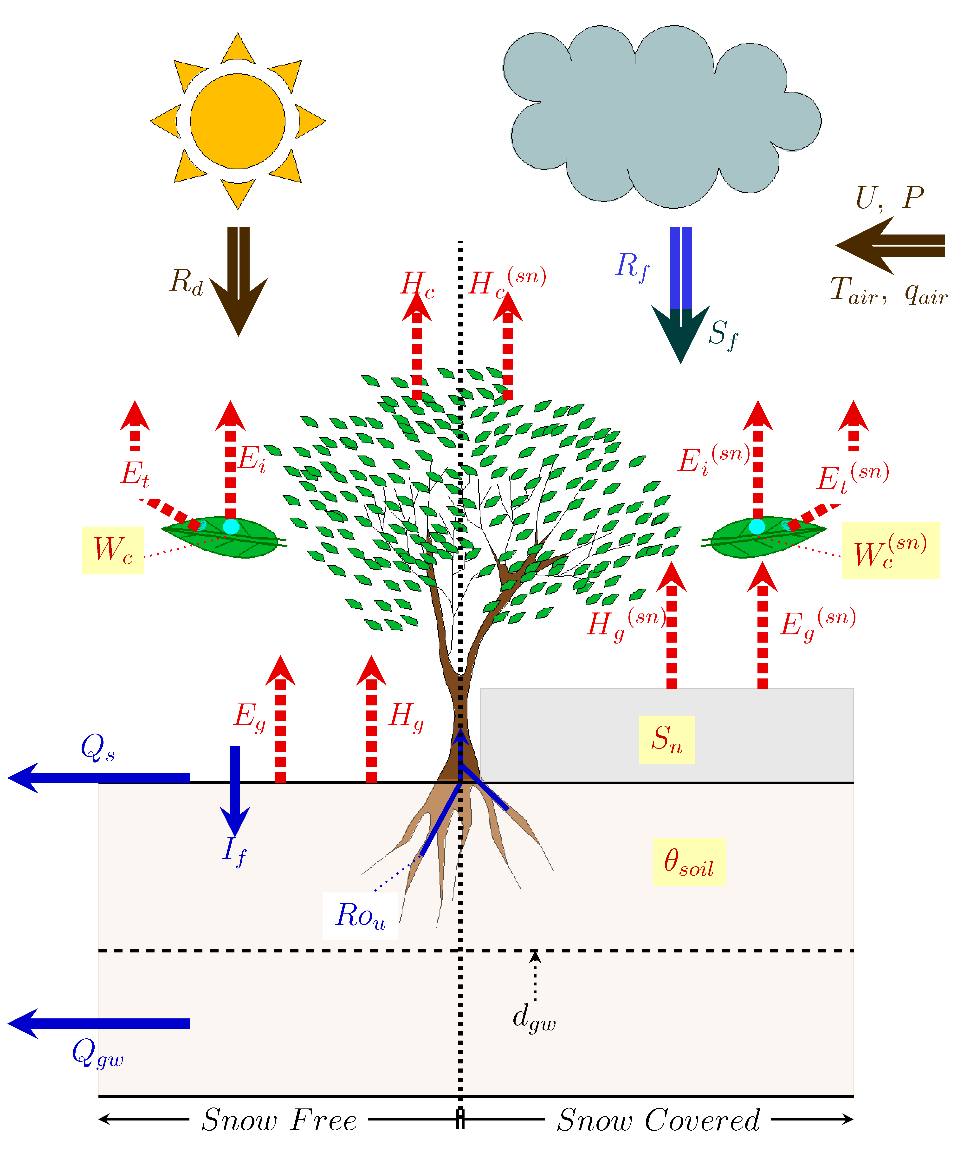
Figure 1. Schematic representation of the original MATSIRO LSM [reproduced from Takata et al., 2003]. Thick arrows denote forcing variables: Rd -downward radiation (shortwave and longwave), Rf -rainfall, Sf -snowfall, U-wind speed, P -surface pressure, Tair -air temperature, and qair -speciﬁc humidity. Broken arrows denote latent heat and sensible heat ﬂuxes: Hg sensible heat ﬂux from ground, Hc sensible heat ﬂux from canopy, Eg-soil evaporation, Et-plant transpiration, and Ei -canopy evaporation. sn in parentheses indicate variables in snow covered fraction. Thin solid arrows denote hydrological ﬂuxes: If -inﬁltration, Qs -surface runoﬀ, Qgw baseﬂow, and Rou -root uptake. Boxes denote hydrological states: Sn -snow water equivalent, Wc -canopy storage, θsoil -soil moisture content, and dgw -water table depth.
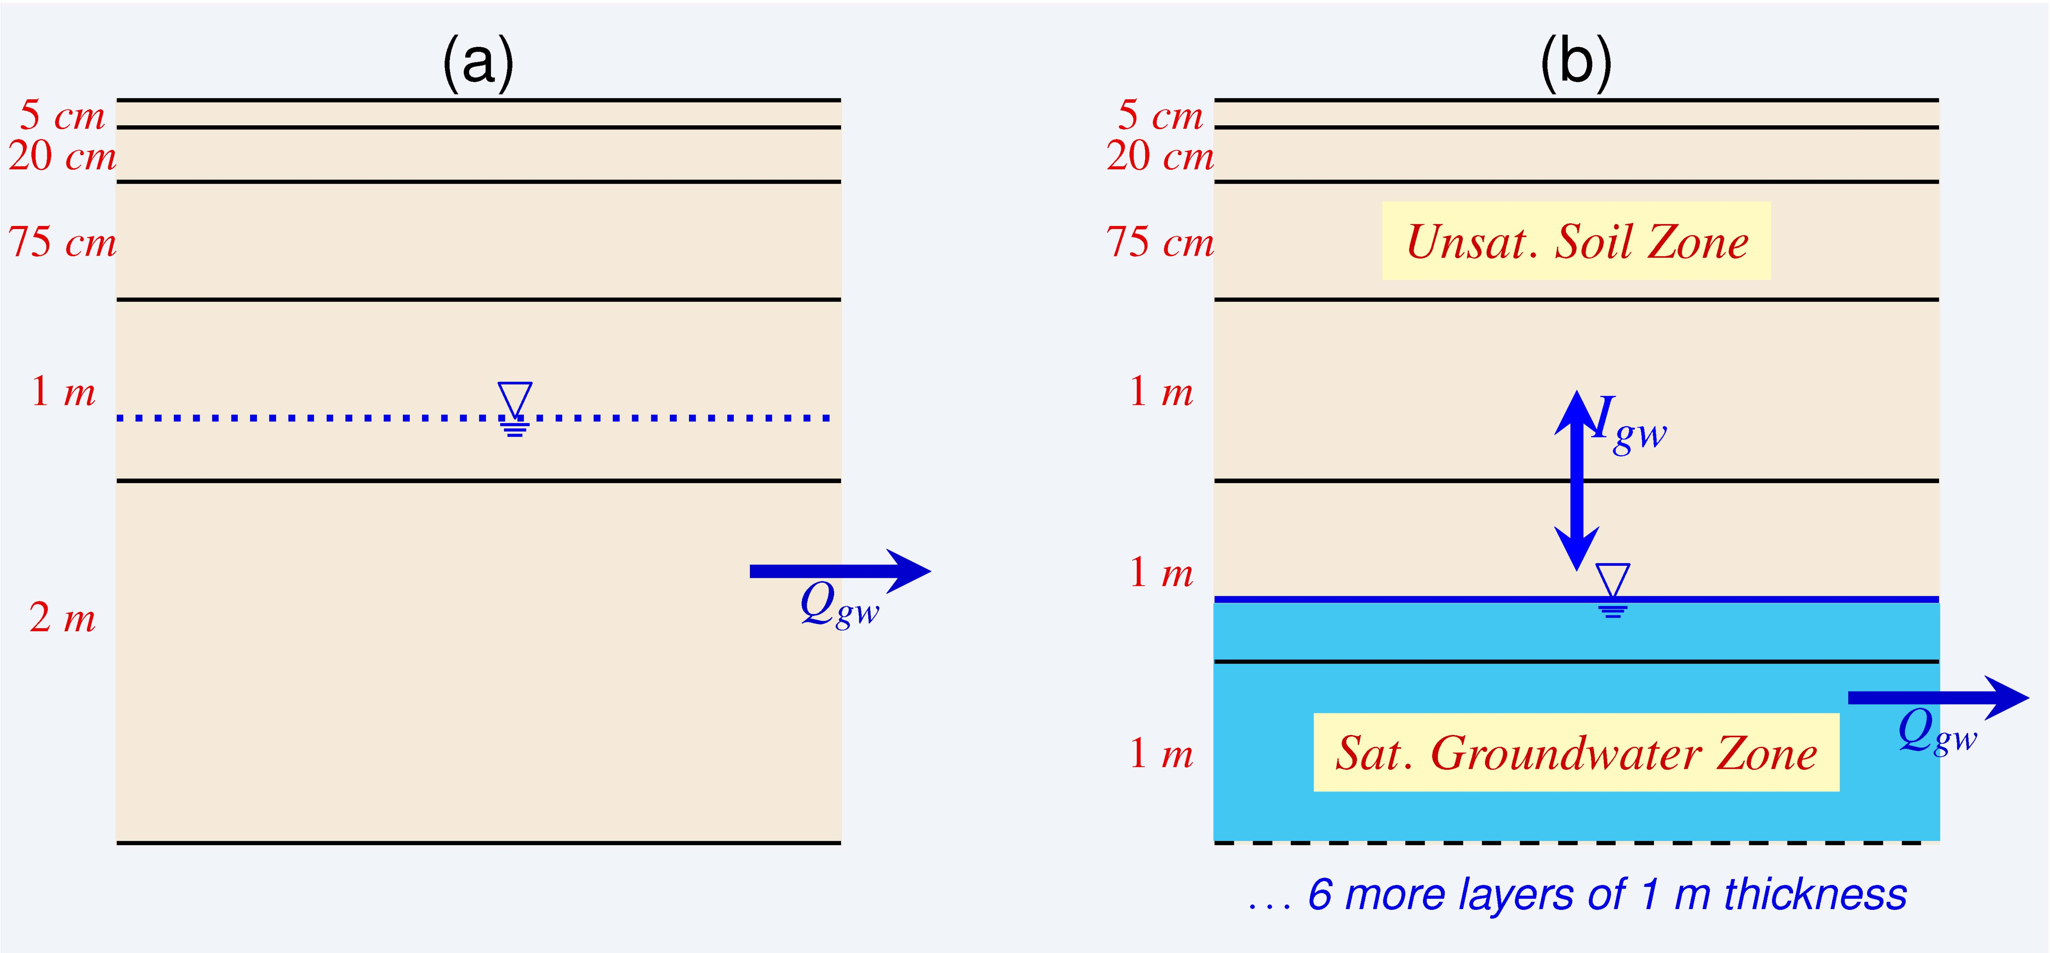
Figure 2. Schematic representation of soil layers and their resolution in (a) MAT-ORI and (b) MAT-GW.
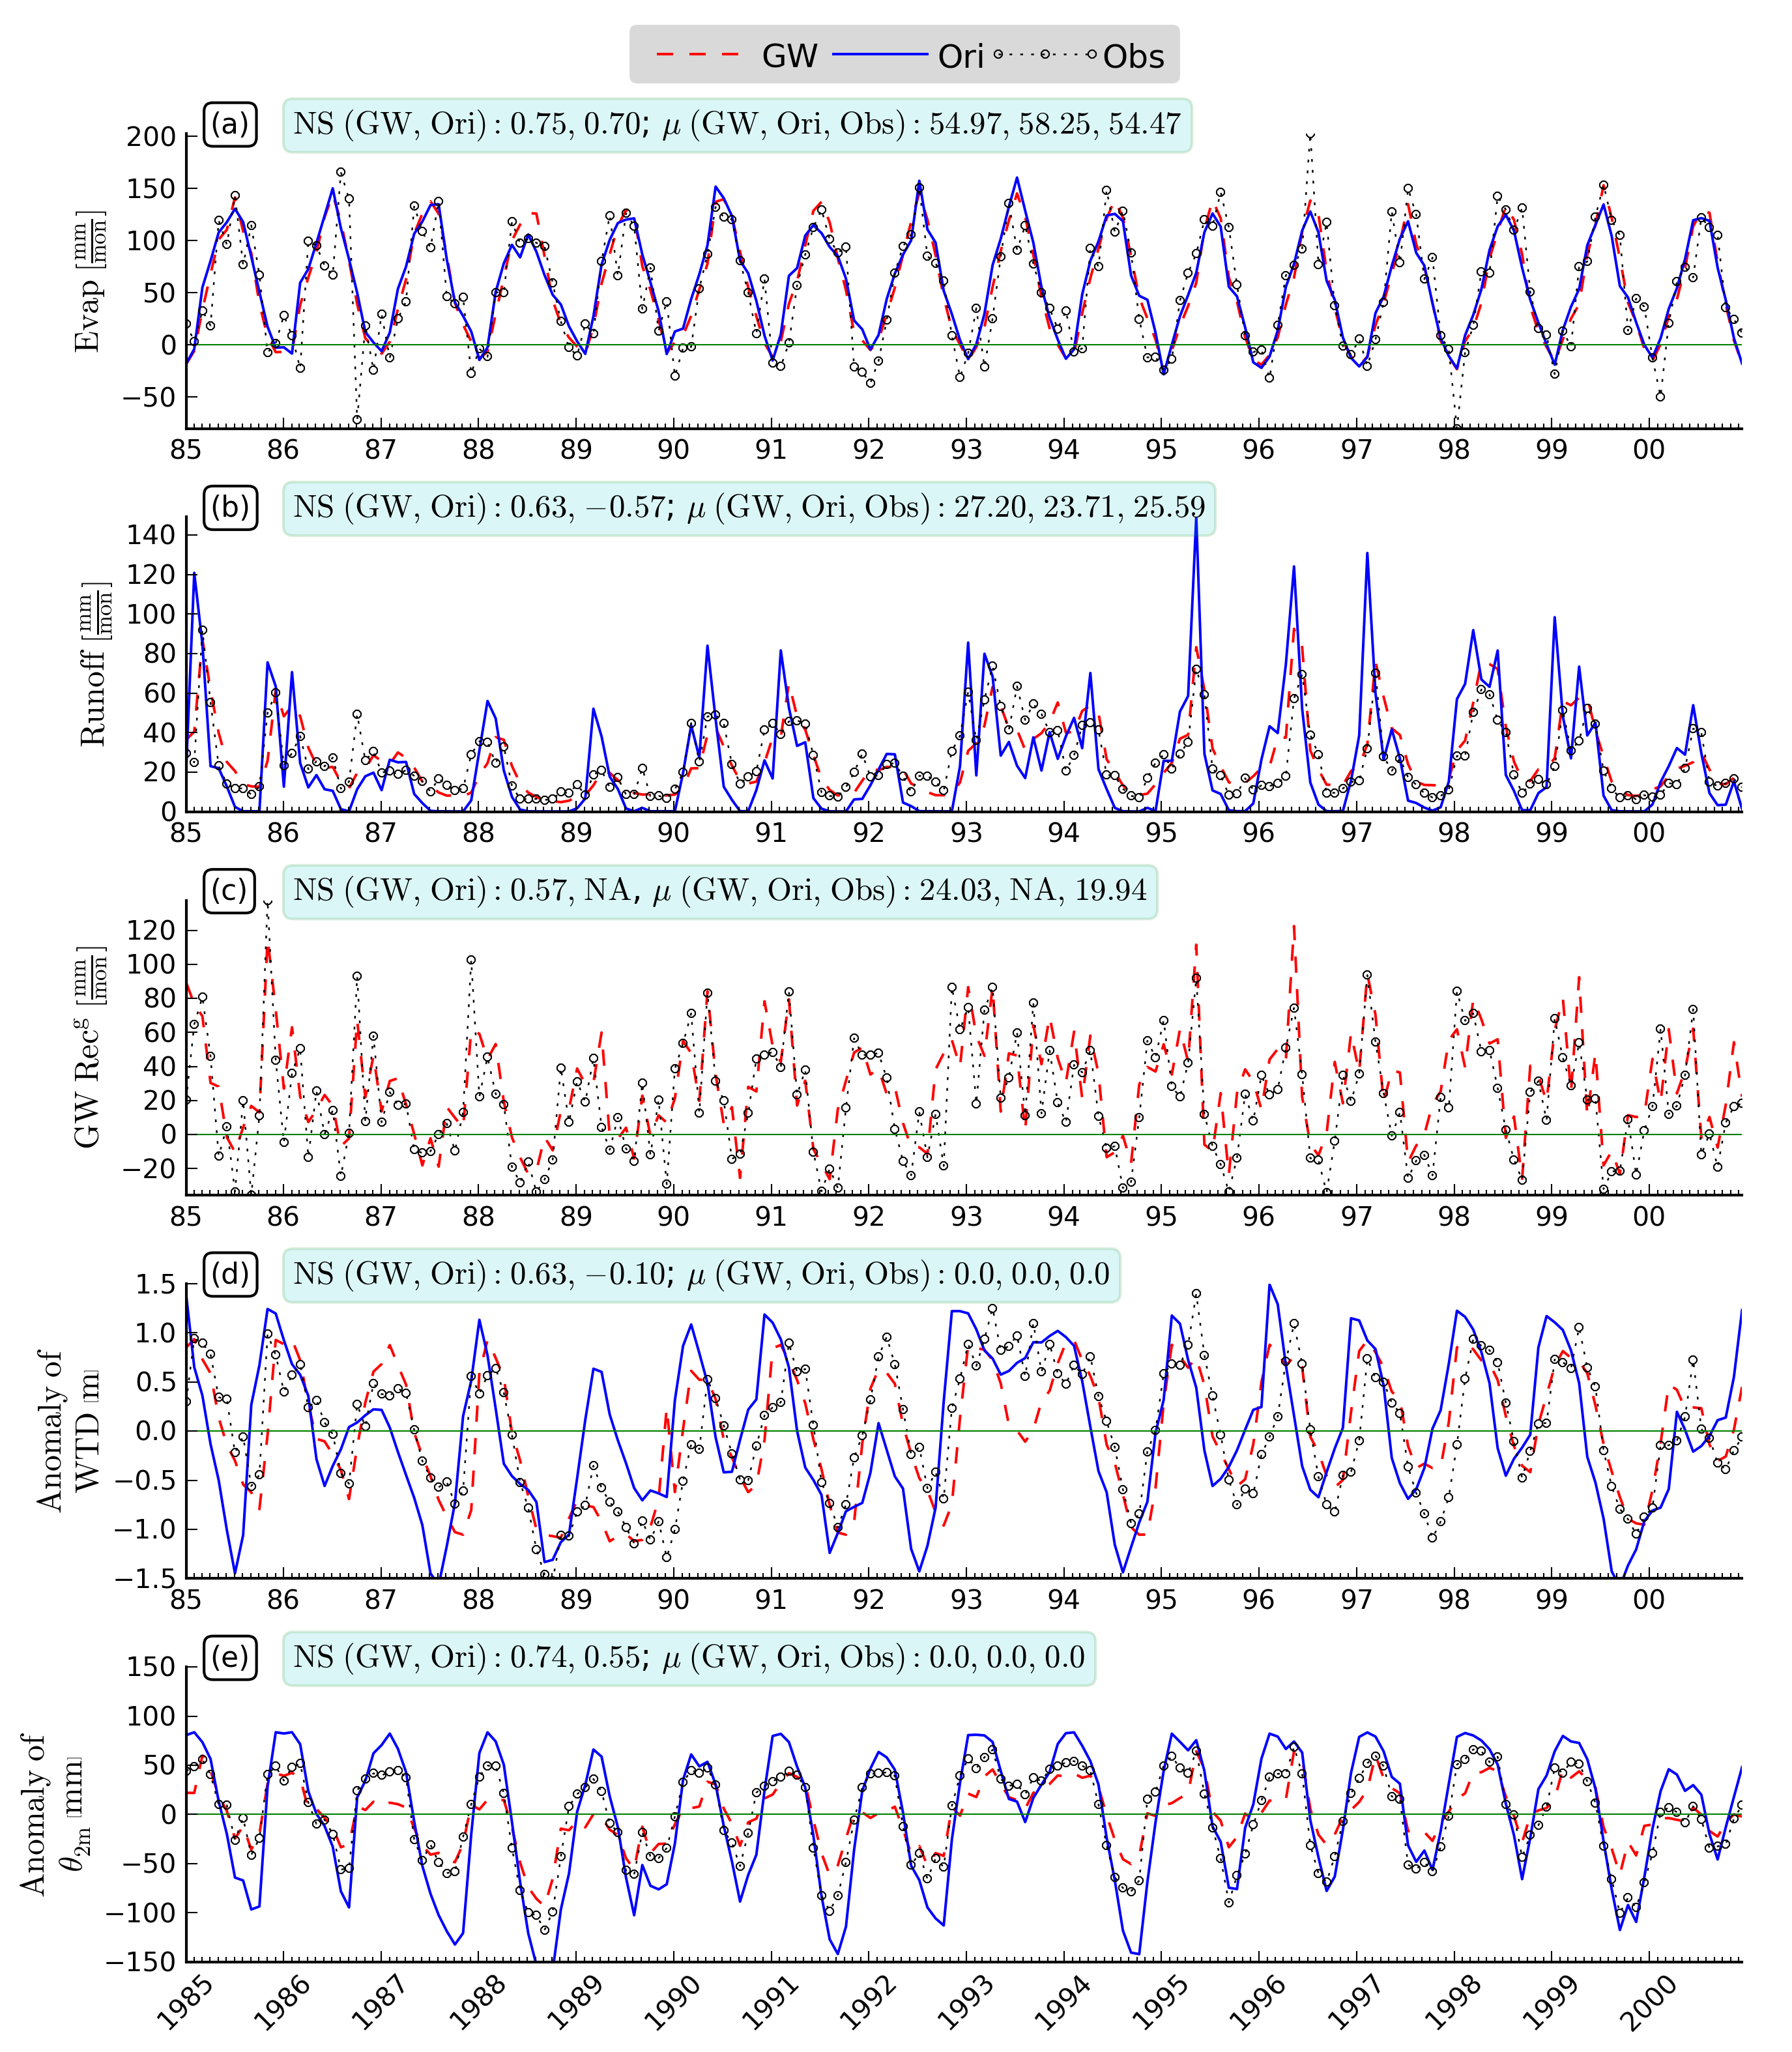
Figure 3. Comparison of the simulations (GW: MAT-GW and Ori: MAT-ORI) against the observations (Obs) of (a) evapotranspiration, (b) total runoﬀ, (c) GW recharge, (d) anomaly of water table depth, and (e) anomaly of moisture in top 2 m soil in the Illinois region.
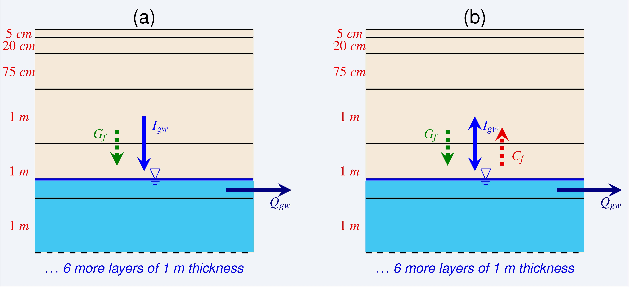
Figure 4. Schematic representation of soil column showing moisture ﬂux exchange between saturated and unsaturated zones for (a) model not considering GW capillary ﬂux (NC), and (b) model considering GW capillary ﬂux (WC).
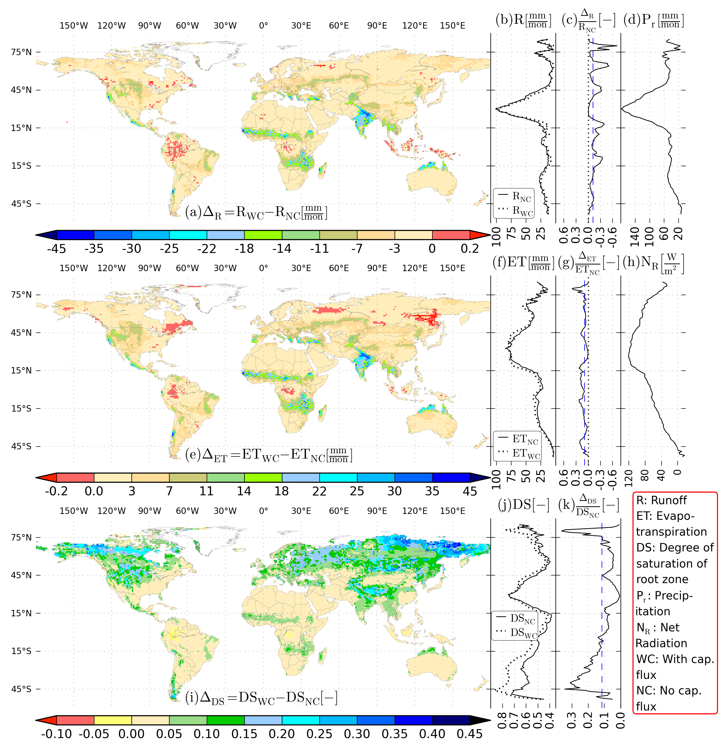Figure 5. Diﬀerence between runoﬀ (R), evapotranspiration (ET), and degree of saturation (DS) of root zone soil moisture in NC and WC simulations. (a), (e), and (h): global map of RWC RNC, ETWC-ETNC, and DSWC-DSNC, respectively. (b), (f), and (j): latitudinal mean of RWC and RNC, ETWC and ETNC, and DSWC and DSNC, respectively. (c), (g), and (k): latitudinal mean of fractional change of R, ET, and DS, respectively, in which dashed line indicates mean. (d), and (h): latitudinal mean of precipitation, and net radiation, respectively.
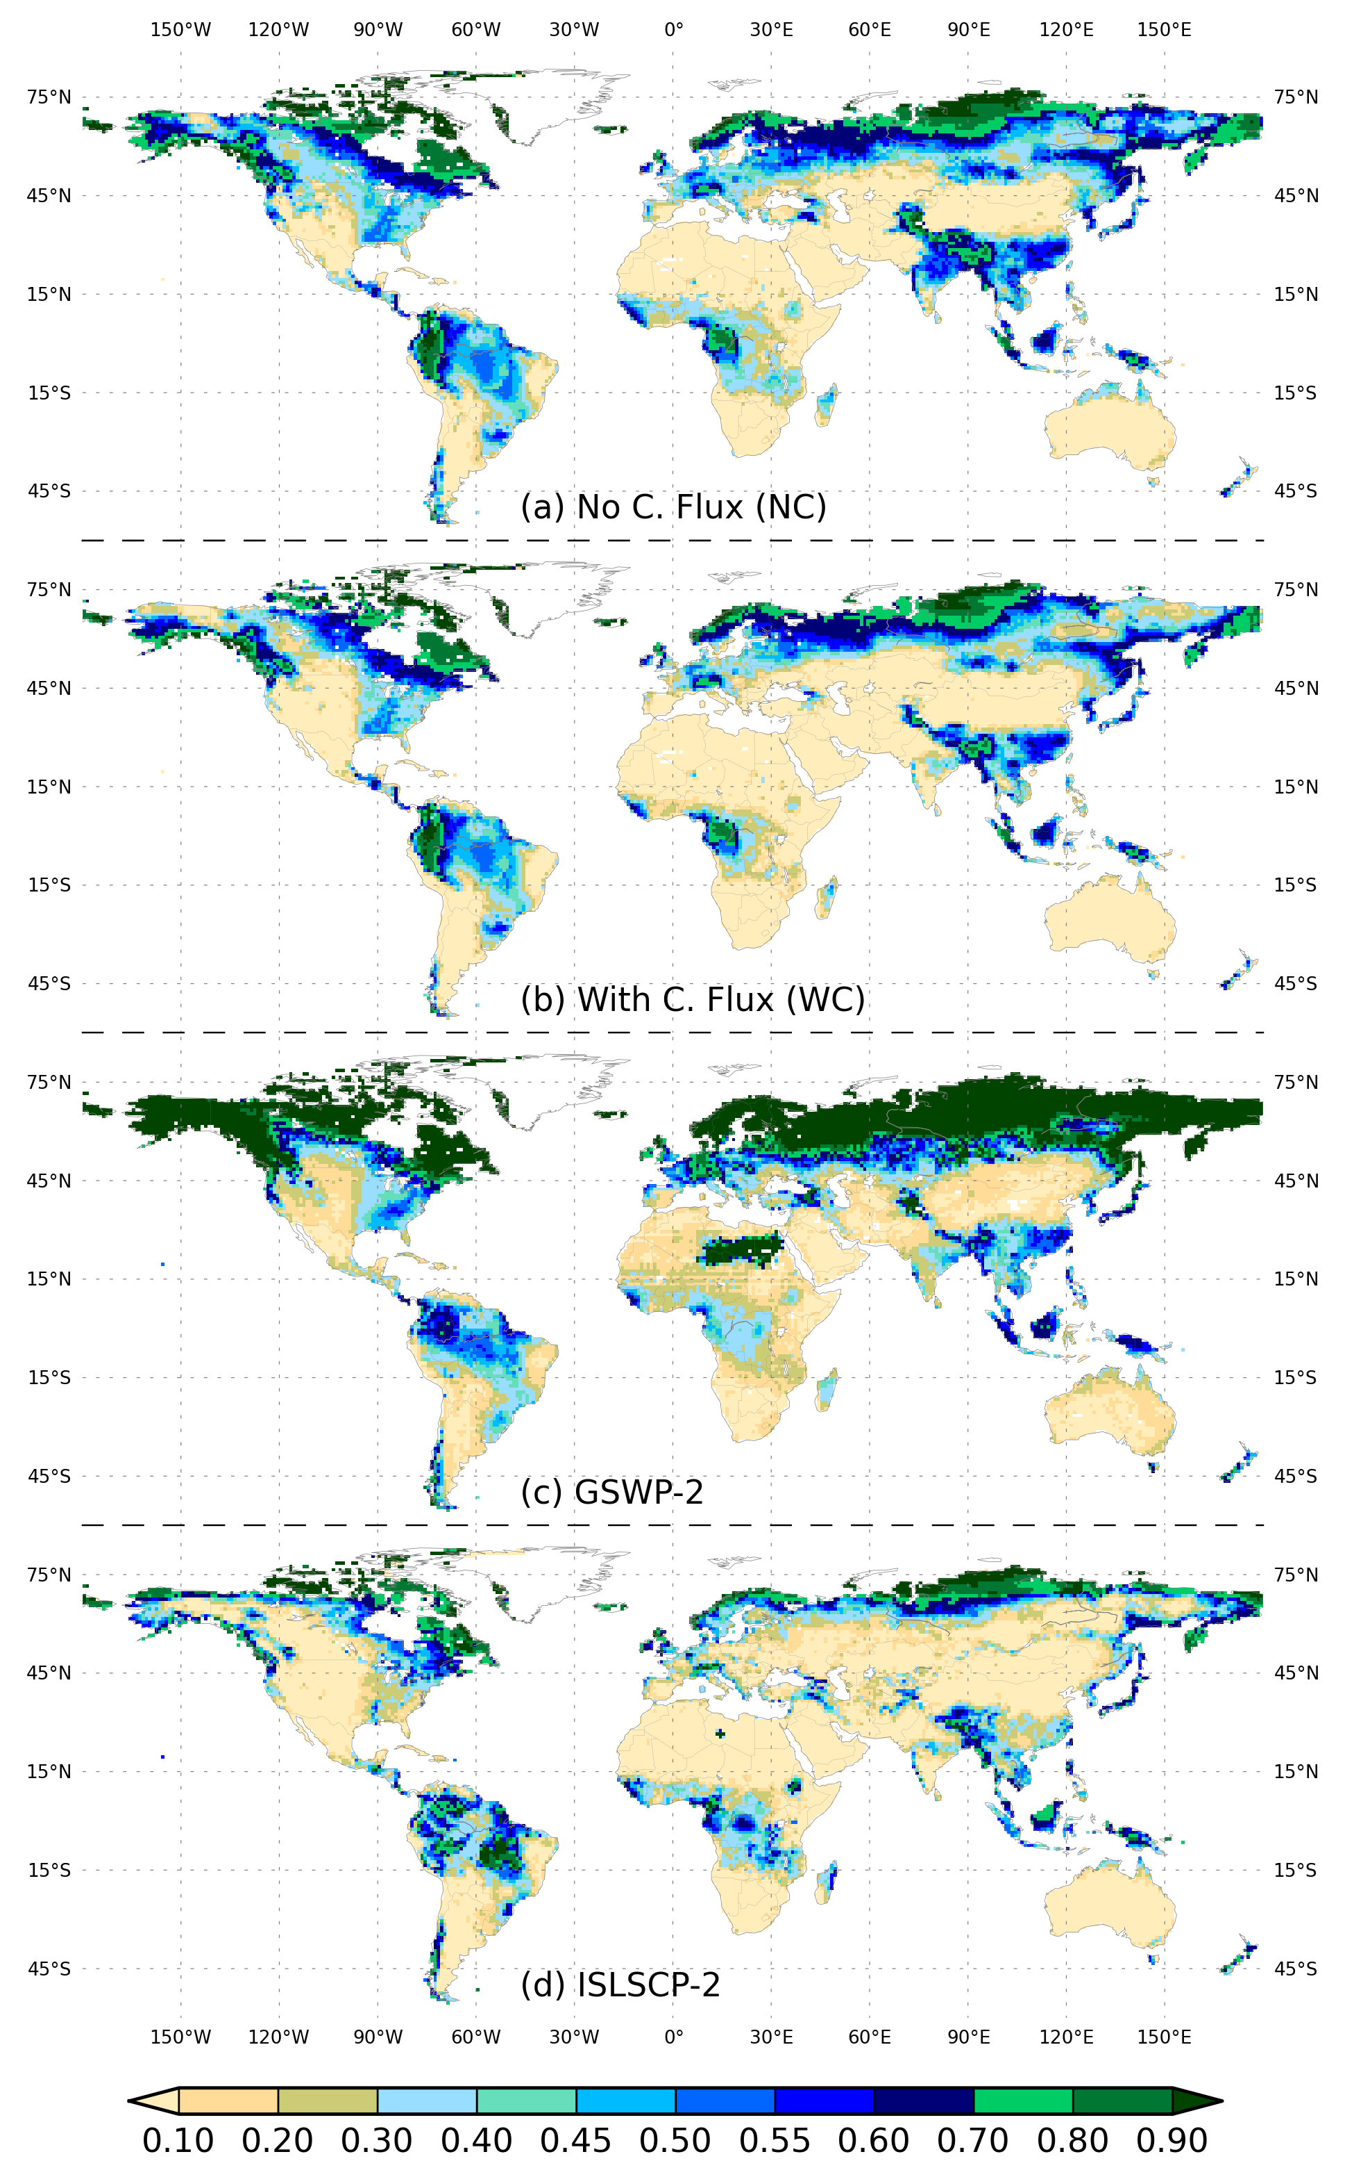
Figure 6. Global distribution of runoﬀ ratio (-) for (a) model not considering capillary ﬂux (NC), (b) model considering capillary ﬂux (WC), (c) GSWP-2 [Dirmeyer et al., 2006], and (d) ISLSCP-2 [Hall et al., 2006].
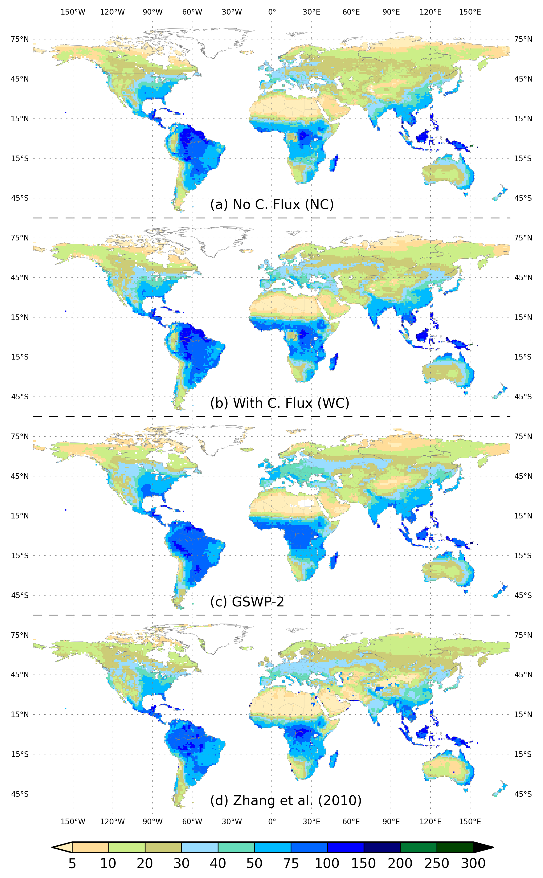
Figure 7. Global distribution of mean evapotranspiration (mm/mon) for (a) model not considering capillary ﬂux (NC), (b) model considering capillary ﬂux (WC), (c) GSWP-2 [Dirmeyer et al., 2006], and (d) satellite-based estimate [Zhang et al., 2009, 2010].

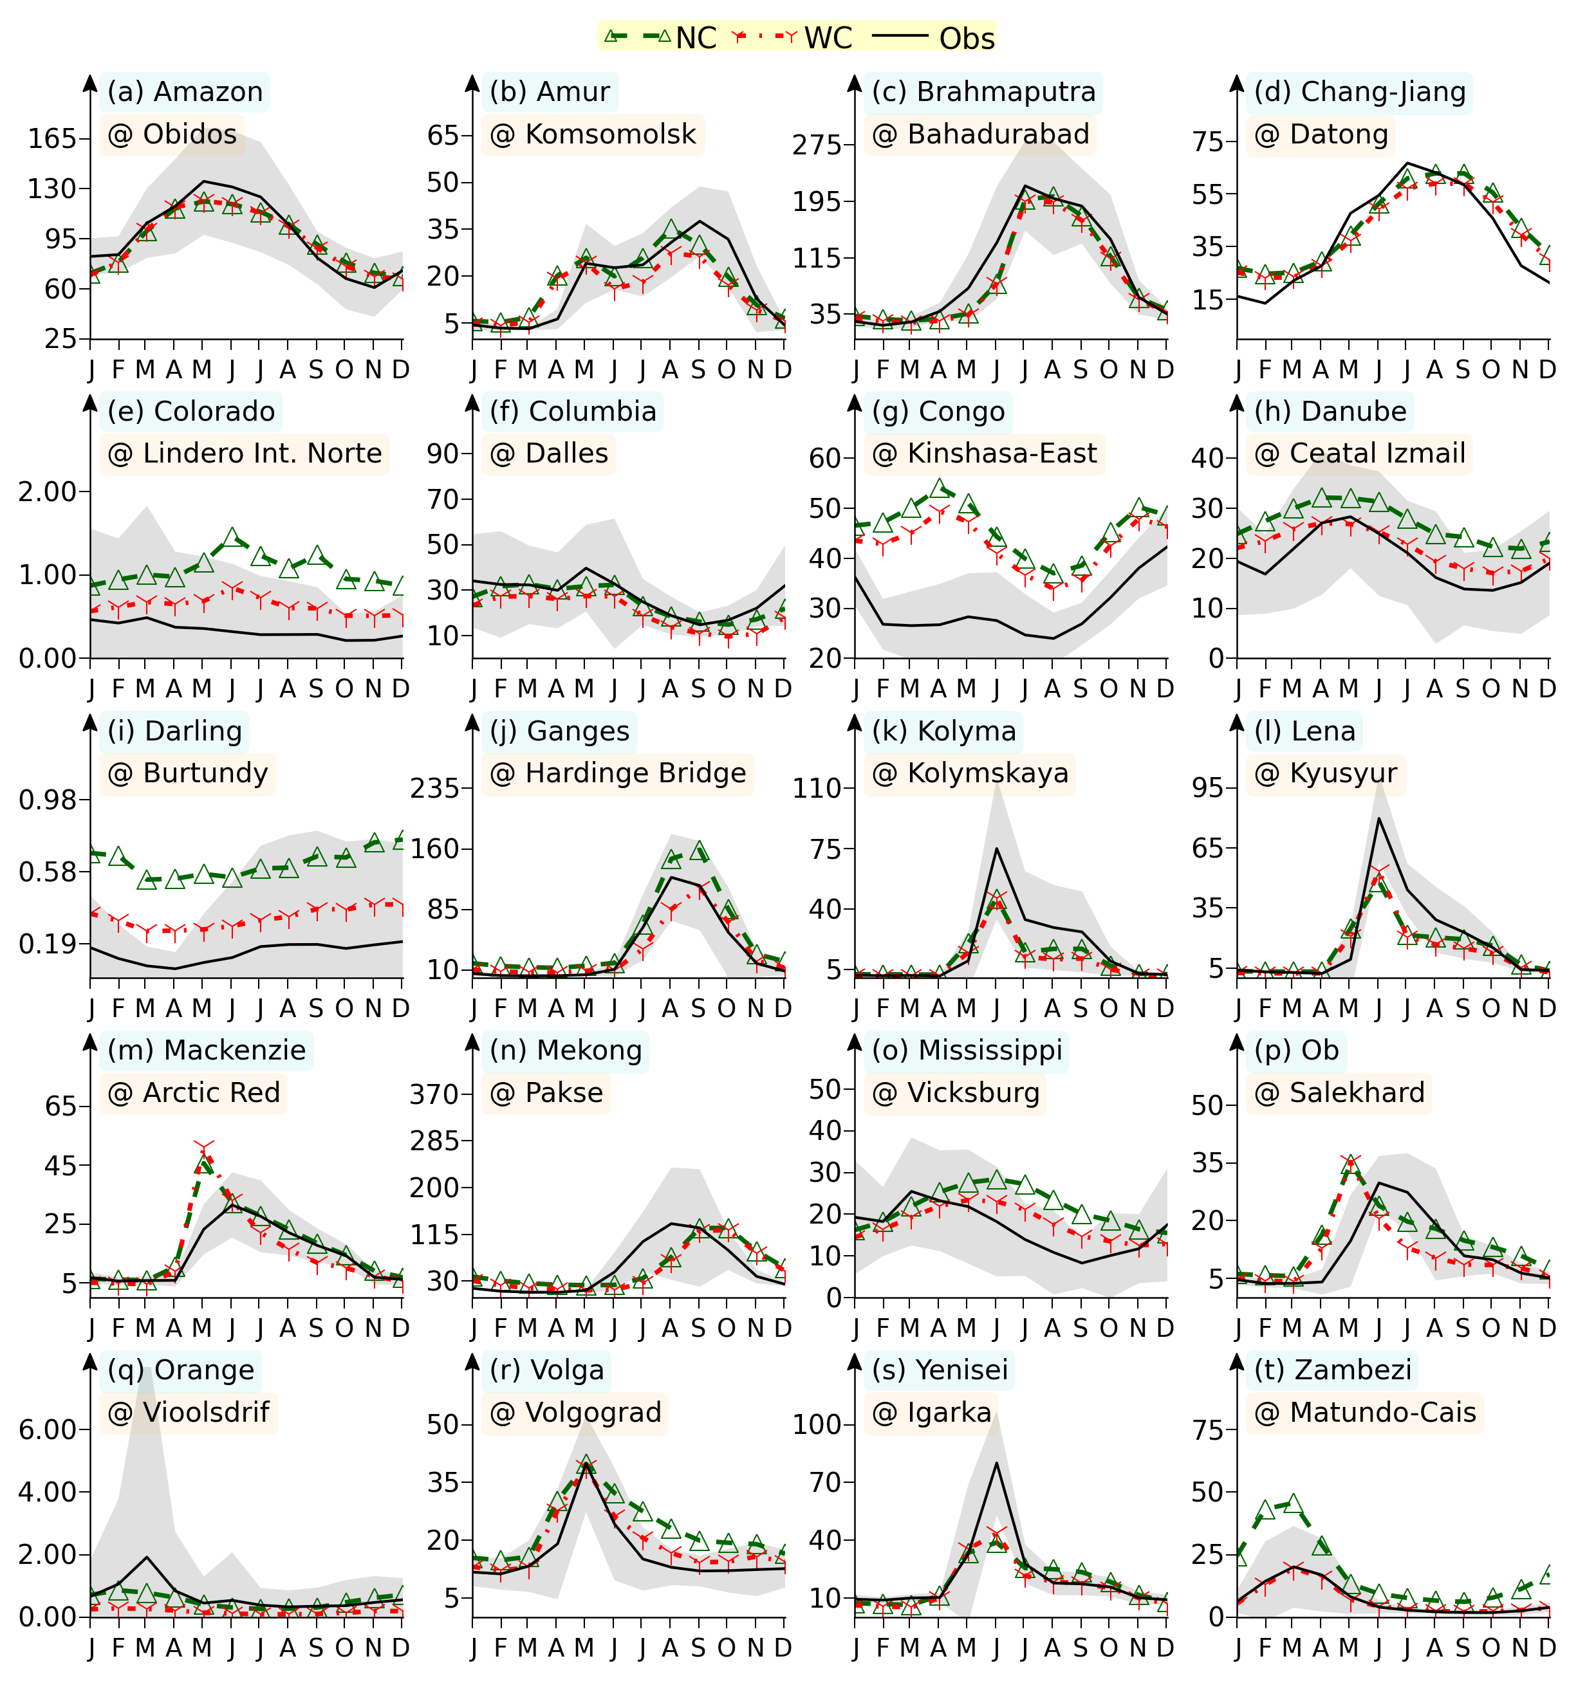Figure 8. Comparison of river discharge (mm/mon) in NC and WC simulations with the GRDC observations in 20 selected river basins. Shaded region indicates values within ± 2 σ.
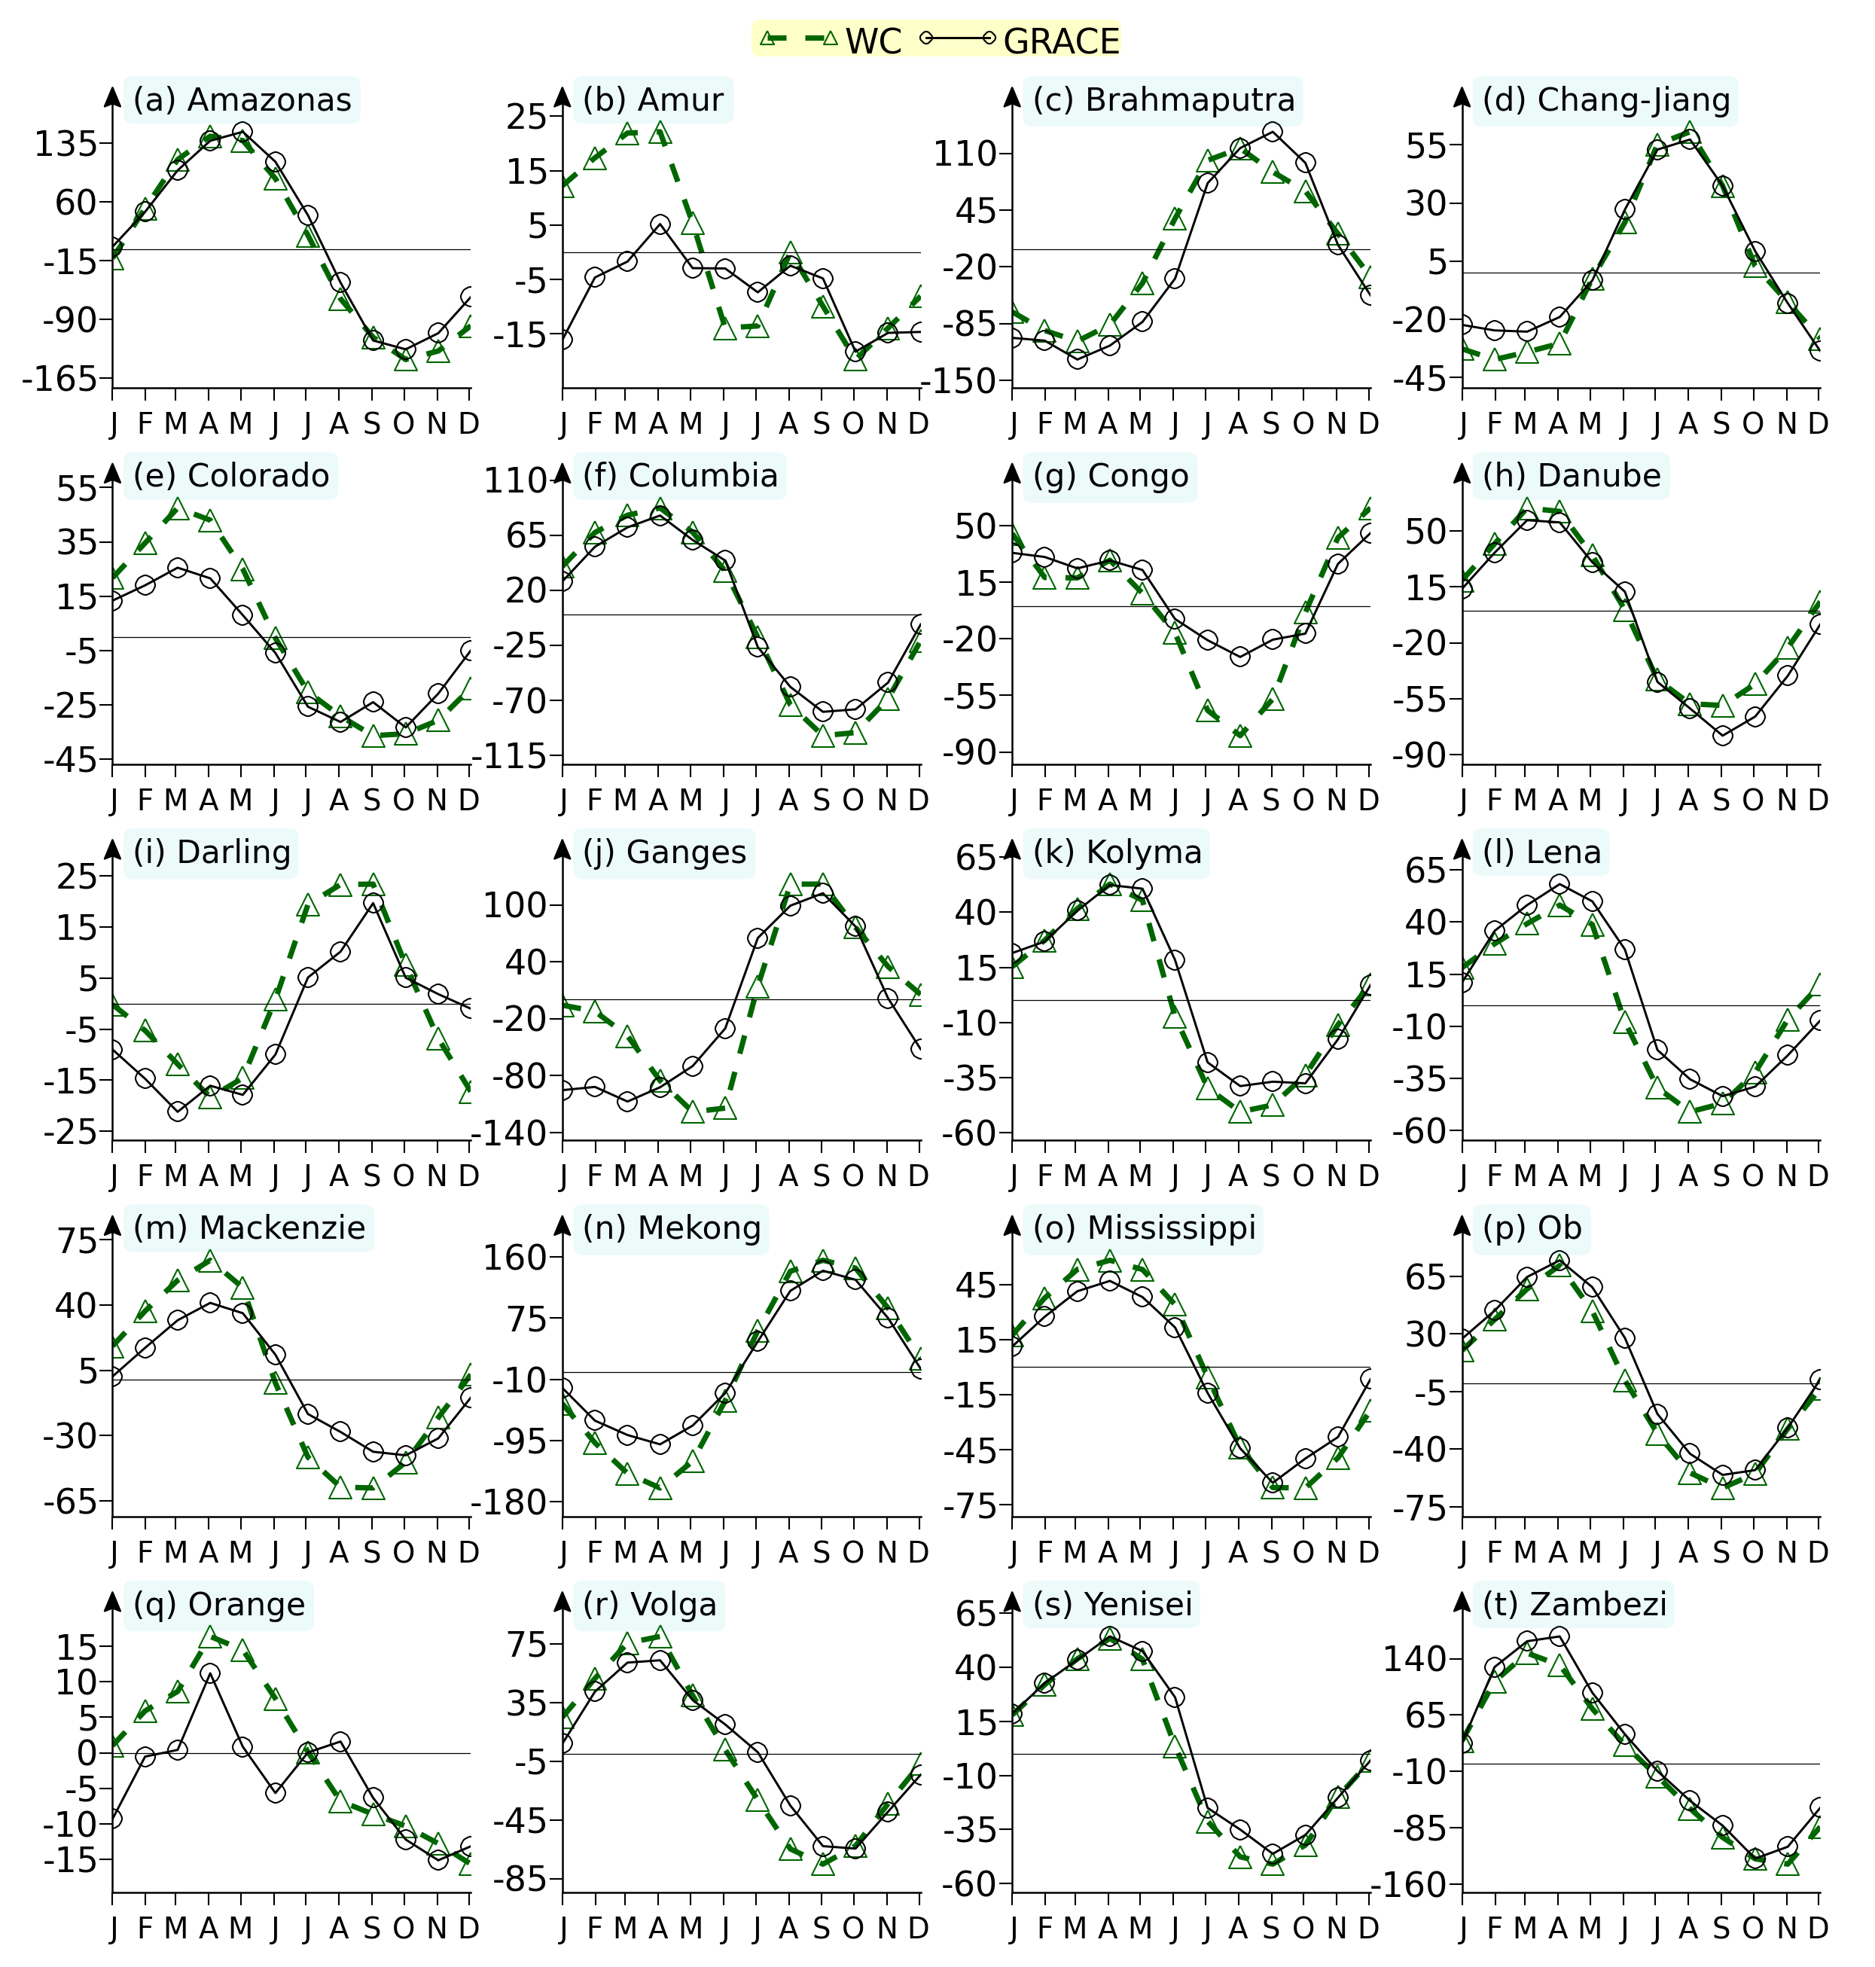
Figure 9. Comparison of terrestrial water storage anomaly (TWSA) in NC and WC simulations with the GRACE TWSA in 20 selected river basins.
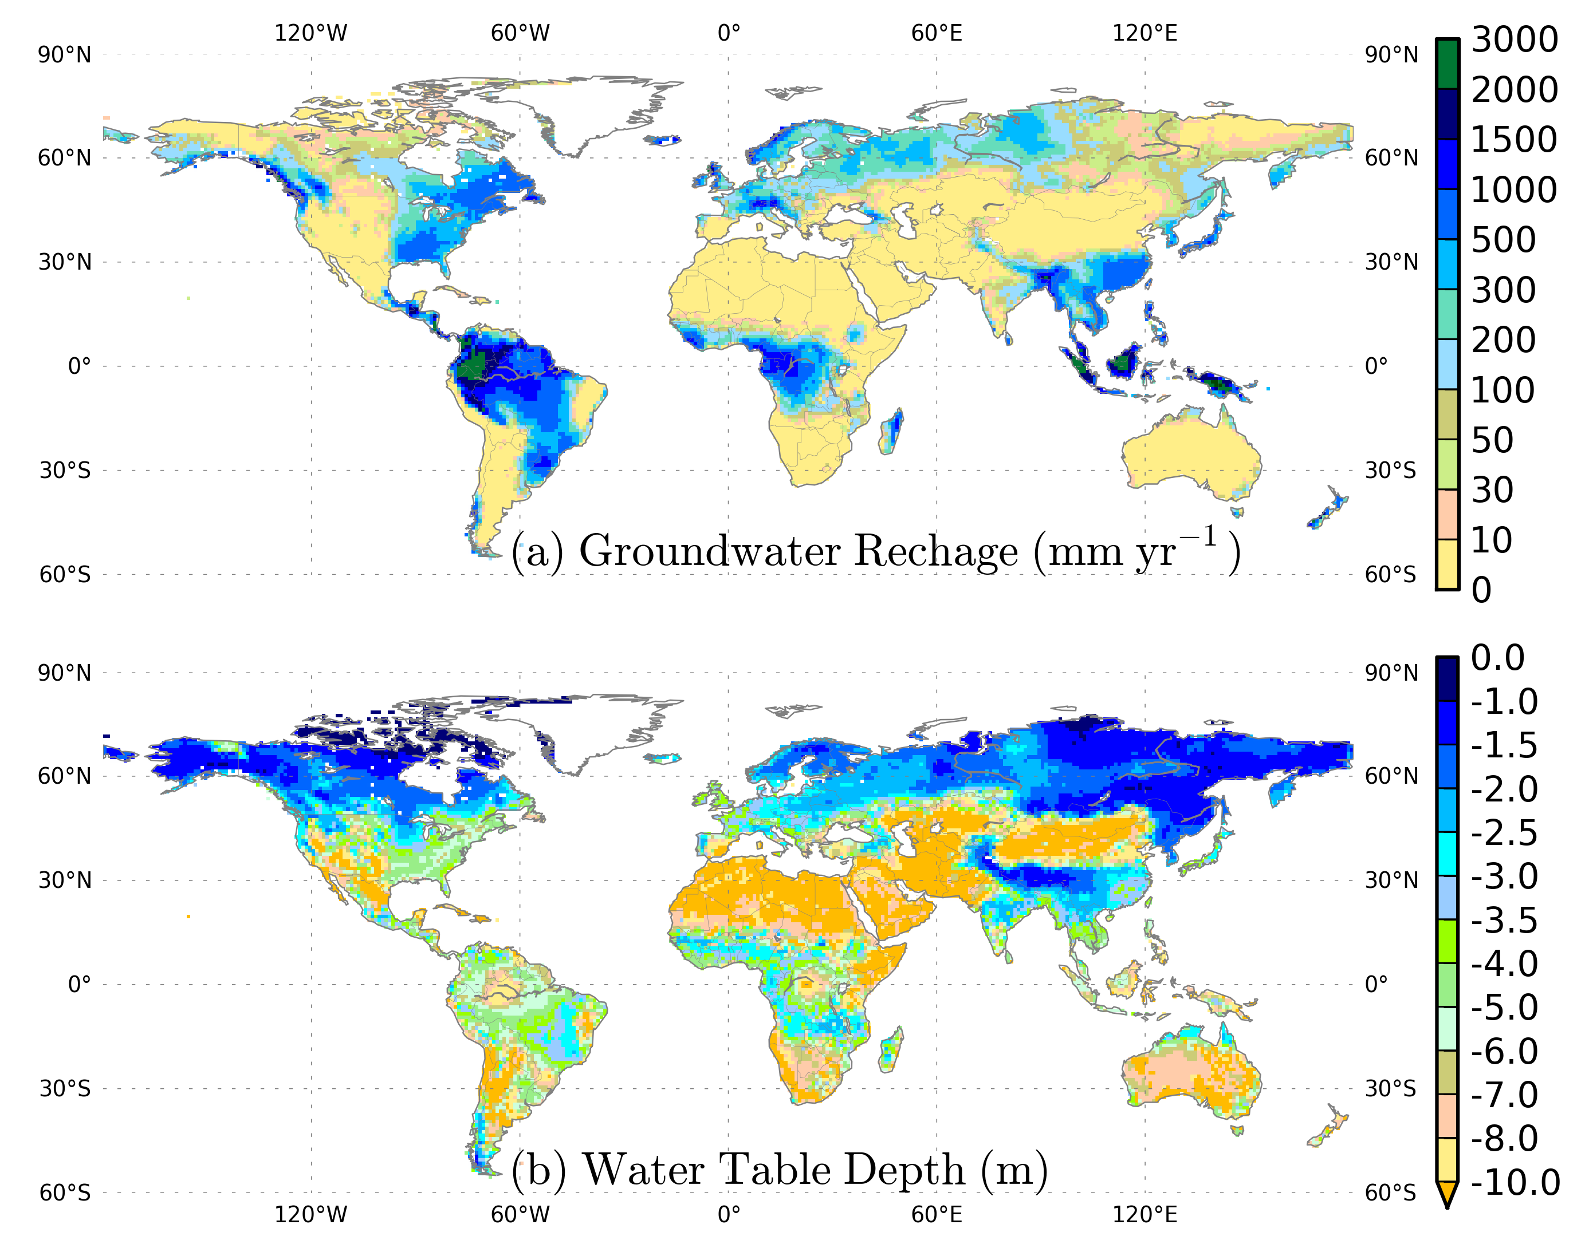
Figure 10. Global distribution of (a) GW recharge (mm/yr), and (b) water table depth (m) in the WC simulation.

